Table of Contents

**What is HTML ?** 7

**HTML Element?** 7

Empty HTML Elements 8

Nested HTML Elements 8

**Web Browsers** 9

**HTML Page Structure** 9

**SEO tags (Search Engine Optimization) , <meta>** 10

HTML <meta> Tag 10

What is a Canonical Tag? 11

<meta name =”robots” content=”index”>. 12

**First html code .** 13

**How to see any web page HTML code(ctrl+U)** 13

**<!DOCTYPE> Declaration** 13

**HTML Headings** 13

Heading 1 14

**HTML Paragraphs** 15

**HTML Horizontal Rules <hr>** 15

**HTML Line Breaks(<br>)** 16

**The HTML <pre>** 16

**HTML Links** 17

OUTP 17

HTML Links 17

**HTML Attributes** 18

The href Attribute 18

The href Attribute 18

The src Attribute 19

The width and height Attributes 19

The alt Attribute 19

The style Attribute 20

The lang Attribute 20

The title Attribute 21

The title Attribute 21

**Single or Double Quotes?** 21

**HTML COMMENTS** 23

**HTML Text Formatting** 23

**HTML Formatting Elements** 24

HTML <b> and <strong> Elements 24

HTML <i> and <em> Elements 24

HTML <small> Element 25

HTML <mark> Element 25

HTML <del> Element 25

HTML <ins> Element 25

HTML <sub> Element 26

HTML <sup> Element 26

HTML Quotation and Citation Elements 26

HTML <blockquote> for Quotations 26

HTML <q> for Short Quotations 27

HTML <abbr> for Abbreviations 28

HTML <address> for Contact Information 28

HTML <cite> for Work Title 29

HTML <bdo> for Bi-Directional Override 30

**HTML Links** 30

HTML Links - The target Attribute 31

Absolute URLs vs. Relative URLs 31

HTML Links - Use an Image as a Link 32

Image as a Link 32

Link to an Email Address 33

Link Titles 33

HTML Links - Create Bookmarks 34

Chapter 1 34

Chapter 2 34

Chapter 3 34

Chapter 4 34

Chapter 10 34

**HTML Images** 35

Image Size - Width and Height 36

Width and Height, or Style? 37

Images in Another Folder 38

Images on Another Server/Website 39

Animated Images 39

Image as a Link 39

Image Floating 40

**Marquee tag** 41

**HTML Lists** 41

HTML Ordered Lists 42

An ordered HTML list 42

Control List Counting 43

Nested HTML Lists 44

HTML Unordered Lists 44

An unordered HTML list 44

HTML Description Lists 46

**HTML Tables** 47

Table Cells 47

Table Rows 48

Table Headers 49

Table Border 50

How To Add a Border 50

Collapsed Table Borders 51

Style Table Borders 52

Round Table Borders 52

Dotted Table Borders 53

Border Color 54

HTML Table Sizes 54

HTML Table Width 55

HTML Table Column Width 56

HTML Table Row Height 57

HTML Table Headers 58

HTML Table Headers 59

Vertical Table Headers 60

Align Table Headers 61

Header for Multiple Columns 62

Table Caption 63

HTML Table Padding & Spacing 64

HTML Table - Cell Padding 64

HTML Table - Cell Spacing 66

HTML Table Colspan & Rowspan 67

HTML Table - Colspan 68

HTML Table - Rowspan 69

**HTML Block and Inline Elements** 70

Block-level Elements 71

Inline Elements 72

The <div> Element 74

The <span> Element 75

**HTML Iframes** 76

**Add Audio in HTML** 78

**Add Video in HTML** 78

**Add PDF in HTML** 79

**Embed (add) YOUTUBE video** 79

**Embed (add) google map** 79

**HTML Entities** 80

**HTML Semantic Elements** 82

HTML <section> Element 84

WWF 84

HTML <article> Element 85

Nesting <article> in <section> or Vice Versa? 85

HTML <header> Element 85

HTML <footer> Element 86

HTML <nav> Element 86

HTML <aside> Element 86

HTML <figure> and <figcaption> Elements 86

**Image map** 87

**HTML Forms** 88

The <form> Element 89

The <label> Element 89

HTML Form Attributes 90

The Action Attribute 90

The Target Attribute 91

The Method Attribute 92

The HTML <form> Elements 94

The <input> Element 95

The <select> Element 96

The <textarea> Element 97

The <button> Element 98

The <fieldset> and <legend> Elements 98

The <datalist> Element 99

HTML Input Types 100

Input Type Password 101

Input Type Submit 101

Input Type Reset 102

Input Type Radio 102

Input Type Checkbox 103

Input Type Button 103

Input Type Color 104

Input Type Date 104

Input Type Datetime-local 105

Input Type Email 105

Input Type Image 106

Input Type File 106

Input Type Hidden 107

Input Type Month 108

Input Type Number 108

Input Type Range 110

Input Type Search 110

Input Type Tel 111

Input Type Time 111

Input Type Url 112

Input Type Week 112

HTML Input Attributes 113

The value Attribute 113

The readonly Attribute 113

The disabled Attribute 114

The size Attribute 114

The maxlength Attribute 115

The min and max Attributes 115

The multiple Attribute 116

The pattern Attribute 116

The placeholder Attribute 117

The required Attribute 117

The step Attribute 118

The autofocus Attribute 118

The list Attribute 119

The autocomplete Attribute 119

**HTML Favicon** 120

**How to add or link style tag with html .** 121

**How to add JS IN html** 122

**(OG TAG OPEN GRAPH TAG FACEBOOK) AND (TWITTER CARD TAG)** 123

**RIGHT TO LEFT A WEB PAGE (AREBIC LANGUAGE)** 123

**W3C AND W3C MARKUP VALIADATION** 124

**HTML Encoding (Character Sets)** 127

**HTML Uniform Resource Locators (URL)** 127

URL - Uniform Resource Locator 127

URL Encoding 129

# **What is HTML ?**

* HTML stands for Hyper Text Markup Language
* HTML is the standard markup language for creating Web pages
* HTML describes the structure of a Web page
* HTML consists of a series of elements
* HTML elements tell the browser how to display the content

# **HTML Element?**

* An HTML element is defined by a start tag, some content, and an end tag:
* <tagname> Content goes here... </tagname>
* The HTML **element** is everything from the start tag to the end tag:
* <h1>My First Heading</h1>
* <p>My first paragraph.</p>

|  |  |  |
| --- | --- | --- |
| **Start tag** | **Element content** | **End tag** |
| <h1> | My First Heading | </h1> |
| <p> | My first paragraph. | </p> |
| <br> | *none* | *none* |

Note: Some HTML elements have no content (like the <br> element). These elements are called empty elements. Empty elements do not have an end tag!

## Empty HTML Elements

HTML elements with no content are called empty elements.

The <br> tag defines a line break, and is an empty element without a closing tag

|  |  |  |
| --- | --- | --- |
| <!DOCTYPE html>  <html>  <body>  <p>This is a <br> paragraph with a line break.</p>  </body>  </html> |  | OUTPUT –  This is a paragraph with a line break. |

## Nested HTML Elements

HTML elements can be nested (this means that elements can contain other elements).

All HTML documents consist of nested HTML elements.

The following example contains four HTML elements (<html>, <body>, <h1> and <p>)

* The <!DOCTYPE html> declaration defines that this document is an HTML5 document
* The <html> element is the root element of an HTML page
* The <head> element contains meta information about the HTML page
* The <title> element specifies a title for the HTML page (which is shown in the browser's title bar or in the page's tab)
* The <body> element defines the document's body, and is a container for all the visible contents, such as headings, paragraphs, images, hyperlinks, tables, lists, etc.
* The <h1> element defines a large heading
* The <p> element defines a paragraph

# **Web Browsers**

The purpose of a web browser (Chrome, Edge, Firefox, Safari) is to read HTML documents and display them correctly.

A browser does not display the HTML tags, but uses them to determine how to display the document .

# **HTML Page Structure**

Below is a visualization of an HTML page structure:

<html>

<head>

<title>Page title</title>

</head>

<body>

<h1>This is a heading</h1>

<p>This is a paragraph.</p>

<p>This is another paragraph.</p>

</body>

</html>

Note: The content inside the <body> section will be displayed in a browser.

The content inside the <title> element will be shown in the browser's title bar or in the page's tab.

# **SEO tags (Search Engine Optimization) , <meta>**

## HTML <meta> Tag

The <meta> tag defines metadata about an HTML document. Metadata is data (information) about data.

<meta> tags always go inside the <head> element, and are typically used to specify character set, page description, keywords, author of the document, and viewport settings.

Metadata will not be displayed on the page, but is machine parsable.

Metadata is used by browsers (how to display content or reload page), search engines (keywords), and other web services.

<head>  
  <meta charset="UTF-8">  
  <meta name="description" content="Free Web tutorials">  
  <meta name="keywords" content="HTML, CSS, JavaScript">  
  <meta name="author" content="John Doe">  
  <meta name="viewport" content="width=device-width, initial-scale=1.0">  
</head>

**Define keywords for search engines:**

<meta name="keywords" content="HTML, CSS, JavaScript">

**Define a description of your web page:**

<meta name="description" content="Free Web tutorials for HTML and CSS">

**Define the author of a page:**

<meta name="author" content="John Doe">

**Refresh document every 30 seconds:**

<meta http-equiv="refresh" content="30">

**Setting the viewport to make your website look good on all devices:**

<meta name="viewport" content="width=device-width, initial-scale=1.0">

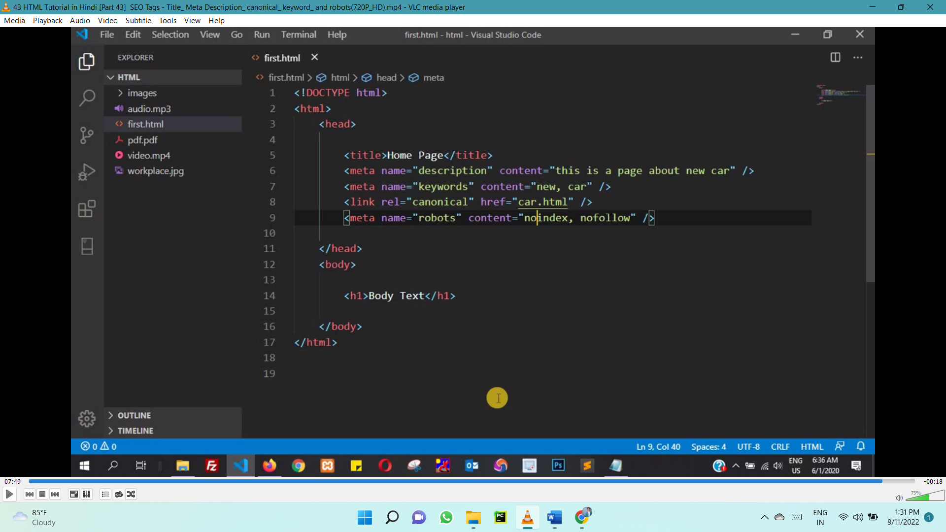

## What is a Canonical Tag?

The canonical tag, also called "rel canonical" is an HTML tag that tells search engines that the enclosed URL is the original, definitive version of the page. The canonicalized URL.

The tag goes in the page’s <head> section and looks like this:

<link rel="canonical” href=”https://www.example.com”>

Practically speaking, the canonical tag tells Google which page you want to appear in search results.

Why Do Canonical Tags Matter?

Humans tend to think of pages that look the same and have the same content as all one page. Like the homepage is the homepage is the homepage. Search engines, though, don’t work the same way. They see different URLs as different pages, even if they serve the same purpose.

So to Google, all of these URLs are unique pages:

* https://www.example.com
* www.example.com/
* https://www.example.com/index.php
* example.com

To Google, you’ve got 5 unique copies of your homepage even though all humans will see is one page. This situation can cause you to suffer some of the issues associated with [duplicate content](https://www.woorank.com/en/edu/seo-guides/duplicate-content).

## <meta name =”robots” content=”index”>.

What the heck is it!? Is it a robot that automates your meta tags? Is it a piece of magical SEO tag? Does it summon the Google robot to your page?

Meta robots tag is a tag that tells search engines what to follow and what not to follow. It is a piece of code in the <head> section of your webpage. It’s a simple code that gives you the power to decide about what pages you want to hide from search engine crawlers and what pages you want them to index and look at.

Another function of the meta robots tag is that it tells [search engine crawlers](https://seo-hacker.com/learn-seo-beginners/) what links to follow and what links to stop with.

When you have a lot of links going out of your website you should know that you lose some Google juice. And as a result, your page rank would lower down.

So what you want to do is to keep that juice to yourself with some of the links—and you tell the search engine crawlers not to follow the links going out of your site because in doing so, they will also take some of your Google juice with them.

If you don’t have a meta robots tag though, don’t panic. By default, the search engine crawlers WILL index your site and WILL follow links.

Let me make it clear that search engine crawlers following your links is not bad at all. Losing some of your juice won’t affect your site much in exchange for getting the attention of other websites you’re linking out to.

In fact I don’t recommend using nofollow at all if you don’t have too much outbound links.

Basically the meta robots tag can be cracked down to four main functions for the search engine crawlers:

* FOLLOW – a command for the search engine crawler to follow the links in that webpage
* INDEX – a command for the search engine crawler  to index that webpage
* NOFOLLOW – a command for the search engine crawler NOT to follow the links in that webpage
* NOINDEX – a command for the search engine crawler NOT to index that webpage

# **First html code .**

Made a file (first.html). drag the file and open in (vs code) .

# **How to see any web page HTML code(ctrl+U)**

# **<!DOCTYPE> Declaration**

The <!DOCTYPE> declaration represents the document type, and helps browsers to display web pages correctly.

It must only appear once, at the top of the page (before any HTML tags).

The <!DOCTYPE> declaration is not case sensitive.

The <!DOCTYPE> declaration for HTML5 is:

<!DOCTYPE html>

# **HTML Headings**

HTML headings are defined with the <h1> to <h6> tags.

<h1> defines the most important heading. <h6> defines the least important heading:

<!DOCTYPE html>

<html>

<body>

<h1>This is heading 1</h1>

<h2>This is heading 2</h2>

<h3>This is heading 3</h3>

<h4>This is heading 4</h4>

<h5>This is heading 5</h5>

<h6>This is heading 6</h6>

</body>

</html>

Headings Are Important

Search engines use the headings to index the structure and content of your web pages.

Users often skim a page by its headings. It is important to use headings to show the document structure.

<h1> headings should be used for main headings, followed by <h2> headings, then the less important <h3>, and so on.

Note: Use HTML headings for headings only. Don't use headings to make text BIG or bold.

Bigger Headings

Each HTML heading has a default size. However, you can specify the size for any heading with the style attribute, using the CSS font-size property:

|  |  |  |
| --- | --- | --- |
| <!DOCTYPE html>  <html>  <body>  <h1 style="font-size:60px;">Heading 1</h1>  <p>You can change the size of a heading with the style attribute, using the font-size property.</p>  </body>  </html> |  | Heading 1 You can change the size of a heading with the style attribute, using the font-size property. |

# **HTML Paragraphs**

The HTML <p> element defines a paragraph.

A paragraph always starts on a new line, and browsers automatically add some white space (a margin) before and after a paragraph.

<p>This is a paragraph.</p>

**HTML Display**

You cannot be sure how HTML will be displayed.

Large or small screens, and resized windows will create different results.

With HTML, you cannot change the display by adding extra spaces or extra lines in your HTML code.

The browser will automatically remove any extra spaces and lines when the page is displayed:

# **HTML Horizontal Rules <hr>**

The <hr> tag defines a thematic break in an HTML page, and is most often displayed as a horizontal rule.

The <hr> element is used to separate content (or define a change) in an HTML page:

The <hr> tag is an empty tag, which means that it has no end tag

# **HTML Line Breaks(<br>)**

The HTML <br> element defines a line break.

Use <br> if you want a line break (a new line) without starting a new paragraph:

the <br> tag is an empty tag, which means that it has no end tag.

# **The HTML <pre>**

The HTML <pre> element defines preformatted text.

The text inside a <pre> element is displayed in a fixed-width font (usually Courier), and it preserves both spaces and line breaks:

|  |
| --- |
| <!DOCTYPE html>  <html>  <body>  <p>The pre tag preserves both spaces and line breaks:</p>  **<pre>**  My Bonnie lies over the ocean.  My Bonnie lies over the sea.  My Bonnie lies over the ocean.  Oh, bring back my Bonnie to me.  **</pre>**  </body>  </html> |

|  |
| --- |
| The pre tag preserves both spaces and line breaks:  My Bonnie lies over the ocean.  My Bonnie lies over the sea.  My Bonnie lies over the ocean.    Oh, bring back my Bonnie to me. |

Tag Description

<p> Defines a paragraph

<hr> Defines a thematic change in the content

<br> Inserts a single line break

<pre> Defines pre-formatted text

# **HTML Links**

HTML links are defined with the <a> tag:

|  |  |  |
| --- | --- | --- |
| **<!DOCTYPE html>**  **<html>**  **<body>**  **<h2>HTML Links</h2>**  **<p>HTML links are defined with the a tag:</p>**  **<a href="https://www.w3schools.com">This is a link</a>**  **</body>**  **</html>** |  | OUTPHTML Links HTML links are defined with the a tag:  [This is a link](https://www.w3schools.com/) |

The link's destination is specified in the href attribute.

Attributes are used to provide additional information about HTML elements.

# **HTML Attributes**

* All HTML elements can have **attributes**
* Attributes provide **additional information** about elements
* Attributes are always specified in **the start tag**
* Attributes usually come in name/value pairs like: **name="value"**

## The href Attribute

The <a> tag defines a hyperlink. The href attribute specifies the URL of the page the link goes to:

|  |  |  |
| --- | --- | --- |
| <!DOCTYPE html>  <html>  <body>  <h2>The href Attribute</h2>  <p>HTML links are defined with the a tag. The link address is specified in the href attribute:</p>  **<a href ="https://www.w3schools.com">Visit W3Schools</a>**  </body>  </html> |  | The href Attribute HTML links are defined with the a tag. The link address is specified in the href attribute:  [Visit W3Schools](https://www.w3schools.com/) |

## The src Attribute

The <img> tag is used to embed an image in an HTML page. The src attribute specifies the path to the image to be displayed:

**<img src="img_girl.jpg">**

There are two ways to specify the URL in the src attribute:

**1. Absolute URL** - Links to an external image that is hosted on another website. Example: src="https://www.w3schools.com/images/img_girl.jpg".

**Notes:** External images might be under copyright. If you do not get permission to use it, you may be in violation of copyright laws. In addition, you cannot control external images; it can suddenly be removed or changed.

**2. Relative URL** - Links to an image that is hosted within the website. Here, the URL does not include the domain name. If the URL begins without a slash, it will be relative to the current page. Example: src="img_girl.jpg". If the URL begins with a slash, it will be relative to the domain. Example: src="/images/img_girl.jpg".

**Tip:** It is almost always best to use relative URLs. They will not break if you change domain.

## The width and height Attributes

The <img> tag should also contain the width and height attributes, which specify the width and height of the image (in pixels):

<img src="img_girl.jpg" width="500" height="600">

## The alt Attribute

The required alt attribute for the <img> tag specifies an alternate text for an image, if the image for some reason cannot be displayed. This can be due to a slow connection, or an error in the src attribute, or if the user uses a screen reader.

<img src="img_girl.jpg" alt="Girl with a jacket">

## The style Attribute

The style attribute is used to add styles to an element, such as color, font, size, and more.

<p style="color:red;">This is a red paragraph.</p>

## The lang Attribute

You should always include the lang attribute inside the <html> tag, to declare the language of the Web page. This is meant to assist search engines and browsers.

The following example specifies English as the language:

<!DOCTYPE html>  
<html lang="en">  
<body>  
...  
</body>  
</html>

Country codes can also be added to the language code in the lang attribute. So, the first two characters define the language of the HTML page, and the last two characters define the country.

The following example specifies English as the language and United States as the country:

<!DOCTYPE html>  
<html lang="en-US">  
<body>  
...  
</body>  
</html>

## The title Attribute

The title attribute defines some extra information about an element.

The value of the title attribute will be displayed as a tooltip when you mouse over the element:

|  |  |
| --- | --- |
| <!DOCTYPE html>  <html>  <body>  <h2 title="I'm a header">The title Attribute</h2>  <p title="I'm a tooltip">Mouse over this paragraph, to display the title attribute as a tooltip.</p>  </body>  </html> | The title Attribute Mouse over this paragraph, to display the title attribute as a tooltip. |

# **Single or Double Quotes?**

Double quotes around attribute values are the most common in HTML, but single quotes can also be used.

In some situations, when the attribute value itself contains double quotes, it is necessary to use single quotes:

<p title='John "ShotGun" Nelson'>

Or vice versa:

<p title="John 'ShotGun' Nelson">

* All HTML elements can have **attributes**
* The href attribute of <a> specifies the URL of the page the link goes to
* The src attribute of <img> specifies the path to the image to be displayed
* The width and height attributes of <img> provide size information for images
* The alt attribute of <img> provides an alternate text for an image
* The style attribute is used to add styles to an element, such as color, font, size, and more
* The lang attribute of the <html> tag declares the language of the Web page
* The title attribute defines some extra information about an element

# **HTML COMMENTS**

HTML comments are not displayed in the browser, but they can help document your HTML source code.

You can add comments to your HTML source by using the following syntax:

<!-- Write your comments here -->

Hide Inline Content

Comments can be used to hide parts in the middle of the HTML code.

Hide a part of a paragaph:

<p>This <!-- great text --> is a paragraph.</p>

# **HTML Text Formatting**

HTML contains several elements for defining text with a special meaning.

|  |
| --- |
| <!DOCTYPE html>  <html>  <body>  <p><b>This text is bold</b></p>  <p><i>This text is italic</i></p>  <p>This is<sub> subscript</sub> and <sup>superscript</sup></p>  </body>  </html> |

|  |
| --- |
| **This text is bold**  *This text is italic*  This issubscript and superscript |

# **HTML Formatting Elements**

Formatting elements were designed to display special types of text:

* <b>  Bold text
* <strong>  Important text
* <i>  Italic text
* <em>  Emphasized text
* <mark>  Marked text
* <small>  Smaller text
* <del>  Deleted text
* <ins>  Inserted text
* <sub>  Subscript text
* <sup>  Superscript text

## HTML <b> and <strong> Elements

The HTML <b> element defines bold text, without any extra importance.

The HTML <strong> element defines text with strong importance. The content inside is typically displayed in bold.

## HTML <i> and <em> Elements

The HTML <i> element defines a part of text in an alternate voice or mood. The content inside is typically displayed in italic.

Tip: The <i> tag is often used to indicate a technical term, a phrase from another language, a thought, a ship name, etc.

<i>This text is italic</i>

The HTML <em> element defines emphasized text. The content inside is typically displayed in italic.

Tip: A screen reader will pronounce the words in <em> with an emphasis, using verbal stress.

<em>This text is emphasized</em>

## HTML <small> Element

The HTML <small> element defines smaller text:

<small>This is some smaller text.</small>

## HTML <mark> Element

The HTML <mark> element defines text that should be marked or highlighted:

<p>Do not forget to buy <mark>milk</mark> today.</p>

Output - Do not forget to buy milk today.

## HTML <del> Element

The HTML <del> element defines text that has been deleted from a document. Browsers will usually strike a line through deleted text:

<p>My favorite color is <del>blue</del> red.</p>

My favorite color  is red.

## HTML <ins> Element

The HTML <ins> element defines a text that has been inserted into a document. Browsers will usually underline inserted text:

<p>My favorite color is <del>blue</del> <ins>red</ins>.</p>

My favorite color is  red.

## HTML <sub> Element

The HTML <sub> element defines subscript text. Subscript text appears half a character below the normal line, and is sometimes rendered in a smaller font. Subscript text can be used for chemical formulas, like H2O:

<p>This is <sub>subscripted</sub> text.</p>

This is subscripted text.

## HTML <sup> Element

The HTML <sup> element defines superscript text. Superscript text appears half a character above the normal line, and is sometimes rendered in a smaller font. Superscript text can be used for footnotes, like WWW[1]:

<p>This is <sup>superscripted</sup> text.</p>

This is superscripted text.

## HTML Quotation and Citation Elements

we will go through the <blockquote>,<q>, <abbr>, <address>, <cite>, and <bdo> HTML elements.

## HTML <blockquote> for Quotations

The HTML <blockquote> element defines a section that is quoted from another source.

Browsers usually indent <blockquote> elements.

<p>Here is a quote from WWF's website:</p>  
<blockquote cite="http://www.worldwildlife.org/who/index.html">  
For 50 years, WWF has been protecting the future of nature.  
The world's leading conservation organization,  
WWF works in 100 countries and is supported by  
1.2 million members in the United States and  
close to 5 million globally.  
</blockquote>

Output -

Here is a quote from WWF's website:

For 50 years, WWF has been protecting the future of nature. The world's leading conservation organization, WWF works in 100 countries and is supported by 1.2 million members in the United States and close to 5 million globally.

## HTML <q> for Short Quotations

The HTML <q> tag defines a short quotation.

Browsers normally insert quotation marks around the quotation.

<p>WWF's goal is to: <q>Build a future where people live in harmony with nature.</q></p>

Output –

Browsers usually insert quotation marks around the q element.

WWF's goal is to: “Build a future where people live in harmony with nature.”

## HTML <abbr> for Abbreviations

The HTML <abbr> tag defines an abbreviation or an acronym, like "HTML", "CSS", "Mr.", "Dr.", "ASAP", "ATM".

Marking abbreviations can give useful information to browsers, translation systems and search-engines.

**Tip:** Use the global title attribute to show the description for the abbreviation/acronym when you mouse over the element.

<p>The <abbr title="World Health Organization">WHO</abbr> was founded in 1948.</p>

Output –

The WHO was founded in 1948. (when u hover on WHOit show full form)

## HTML <address> for Contact Information

The HTML <address> tag defines the contact information for the author/owner of a document or an article.

The contact information can be an email address, URL, physical address, phone number, social media handle, etc.

The text in the <address> element usually renders in *italic,* and browsers will always add a line break before and after the <address> element.

|  |
| --- |
| <address> Written by John Doe.<br> Visit us at:<br> Example.com<br> Box 564, Disneyland<br> USA </address> |

|  |
| --- |
| *Written by John Doe. Visit us at: Example.com Box 564, Disneyland USA* |

## HTML <cite> for Work Title

The HTML <cite> tag defines the title of a creative work (e.g. a book, a poem, a song, a movie, a painting, a sculpture, etc.).**Note:** A person's name is not the title of a work.The text in the <cite> element usually renders in *italic*.

<!DOCTYPE html>

<html>

<body>

<p>The HTML cite element defines the title of a work.</p>

<p>Browsers usually display cite elements in italic.</p>

<img src="img_the_scream.jpg" width="220" height="277" alt="The Scream">

<p><cite>The Scream</cite> by Edvard Munch. Painted in 1893.</p>

</body>

</html>

Output -

The HTML cite element defines the title of a work.

Browsers usually display cite elements in italic.

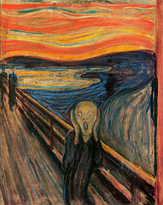

*The Scream* by Edvard Munch. Painted in 1893.

## HTML <bdo> for Bi-Directional Override

BDO stands for Bi-Directional Override.

The HTML <bdo> tag is used to override the current text direction:

<bdo dir="rtl">This </bdo>

Ouput - siht

# **HTML Links**

HTML links are hyperlinks.

You can click on a link and jump to another document.

When you move the mouse over a link, the mouse arrow will turn into a little hand.

Note: A link does not have to be text. A link can be an image or any other HTML element

The HTML <a> tag defines a hyperlink. It has the following syntax:

<a href="*url*">*link text*</a>

The most important attribute of the <a> element is the href attribute, which indicates the link's destination.

The *link text* is the part that will be visible to the reader.

Clicking on the link text, will send the reader to the specified URL address.

<a href="https://www.w3schools.com/">Visit W3Schools.com!</a>

Output - [Visit W3Schools.com!](https://www.w3schools.com/) (when you click on [Visit W3Schools.com!](https://www.w3schools.com/) it send you to https://www.w3schools.com/">)

## HTML Links - The target Attribute

By default, the linked page will be displayed in the current browser window. To change this, you must specify another target for the link.

The target attribute specifies where to open the linked document.

The target attribute can have one of the following values:

* _self - Default. Opens the document in the same window/tab as it was clicked
* _blank - Opens the document in a new window or tab
* _parent - Opens the document in the parent frame
* _top - Opens the document in the full body of the window

Use target="_blank" to open the linked document in a new browser window or tab:

<a href="https://www.w3schools.com/" target="_blank">Visit W3Schools!</a>

Output - [Visit W3Schools!](https://www.w3schools.com/)

## Absolute URLs vs. Relative URLs

Both examples above are using an absolute URL (a full web address) in the href attribute.

A local link (a link to a page within the same website) is specified with a relative URL (without the "https://www" part):

<h2>Absolute URLs</h2>

<p><a href="https://www.w3.org/">W3C</a></p>

<p><a href="https://www.google.com/">Google</a></p>

<h2>Relative URLs</h2>

<p><a href="html_images.asp">HTML Images</a></p>

<p><a href="/css/default.asp">CSS Tutorial</a></p>

Absolute URLs

[W3C](https://www.w3.org/)

[Google](https://www.google.com/)

Relative URLs

[HTML Images](https://www.w3schools.com/html/html_images.asp)

[CSS Tutorial](https://www.w3schools.com/css/default.asp)

## HTML Links - Use an Image as a Link

To use an image as a link, just put the <img> tag inside the <a> tag:

|  |  |  |
| --- | --- | --- |
| <!DOCTYPE html>  <html>  <body>  <h2>Image as a Link</h2>  <p>The image below is a link. Try to click on it.</p>  <a href="default.asp"><img src="smiley.gif" alt="HTML tutorial" style="width:42px;height:42px;"></a>  </body>  </html> |  | Image as a Link The image below is a link. Try to click on it.  [HTML tutorial](https://www.w3schools.com/html/default.asp) |

## Link to an Email Address

Use mailto: inside the href attribute to create a link that opens the user's email program (to let them send a new email):

<a href="mailto:someone@example.com">Send email</a>

## Link Titles

The title attribute specifies extra information about an element. The information is most often shown as a tooltip text when the mouse moves over the element.

<a href="https://www.w3schools.com/html/" title="Go to W3Schools HTML section">Visit our HTML Tutorial</a>

Output - [Visit our HTML Tutorial](https://www.w3schools.com/html/) (when u hover on [Visit our HTML Tutorial](https://www.w3schools.com/html/) it show Go to W3Schools HTML section and when u click on [Visit our HTML Tutorial](https://www.w3schools.com/html/) it redirect you to https://www.w3schools.com/html/"  )

* Use the <a> element to define a link
* Use the href attribute to define the link address
* Use the target attribute to define where to open the linked document
* Use the <img> element (inside <a>) to use an image as a link
* Use the mailto: scheme inside the href attribute to create a link that opens the user's email program

## HTML Links - Create Bookmarks

HTML links can be used to create bookmarks, so that readers can jump to specific parts of a web page.

Create a Bookmark in HTML

Bookmarks can be useful if a web page is very long.

To create a bookmark - first create the bookmark, then add a link to it.

When the link is clicked, the page will scroll down or up to the location with the bookmark.

|  |  |  |
| --- | --- | --- |
| <!DOCTYPE html>  <html>  <body>  <p><a href="#C4">Jump to Chapter 4</a></p>  <p><a href="#C10">Jump to Chapter 10</a></p>  <h2>Chapter 1</h2>  <p>This chapter explains ba bla bla</p>  <h2>Chapter 2</h2>  <p>This chapter explains ba bla bla</p>  <h2 id="C4">Chapter 4</h2>  <p>This chapter explains ba bla bla</p>  <h2>Chapter 6</h2>  <p>This chapter explains ba bla bla</p>  <h2>Chapter 7</h2>  <p>This chapter explains ba bla bla</p>  <h2>Chapter 8</h2>  <p>This chapter explains ba bla bla</p>  <h2>Chapter 9</h2>  <p>This chapter explains ba bla bla</p>  <h2 id="C10">Chapter 10</h2>  <p>This chapter explains ba bla bla</p>  </body>  </html> |  | [Jump to Chapter 4](https://www.w3schools.com/html/tryit.asp?filename=tryhtml_links_bookmark#C4)  [Jump to Chapter 10](https://www.w3schools.com/html/tryit.asp?filename=tryhtml_links_bookmark#C10) Chapter 1 This chapter explains ba bla bla Chapter 2 This chapter explains ba bla bla Chapter 3 This chapter explains ba bla bla Chapter 4 This chapter explains ba bla bla Chapter 10 This chapter explains ba bla bla |

# **HTML Images**

The HTML <img> tag is used to embed an image in a web page.

The <img> tag is empty, it contains attributes only, and does not have a closing tag.

The <img> tag has two required attributes:

* src - Specifies the path to the image
* alt - Specifies an alternate text for the image

<img src="*url*" alt="alternatetext">

**The src Attribute**

The required src attribute specifies the path (URL) to the image.

**The alt Attribute**

The required alt attribute provides an alternate text for an image, if the user for some reason cannot view it (because of slow connection, an error in the src attribute, or if the user uses a screen reader).

The value of the alt attribute should describe the image:

<img src="img_chania.jpg" alt="Flowers in Chania">

## Image Size - Width and Height

You can use the style attribute to specify the width and height of an image.

<img src="img_girl.jpg" alt="Girl in a jacket" style="width:500px;height:600px;">

Alternatively, you can use the width and height attributes:

<img src="img_girl.jpg" alt="Girl in a jacket" width="500" height="600">

The width and height attributes always define the width and height of the image in pixels.

Note: Always specify the width and height of an image. If width and height are not specified, the web page might flicker while the image loads.

## Width and Height, or Style?

The width, height, and style attributes are all valid in HTML.

However, we suggest using the style attribute. It prevents styles sheets from changing the size of images:

<!DOCTYPE html>

<html>

<head>

<style>

/* This style sets the width of all images to 100%: */

img {

width: 100%;

}

</style>

</head>

<body>

<h2>Width/Height Attributes or Style?</h2>

<p>The first image uses the width attribute (set to 128 pixels), but the style in the head section overrides it, and sets the width to 100%.</p>

<img src="html5.gif" alt="HTML5 Icon" width="128" height="128">

<p>The second image uses the style attribute to set the width to 128 pixels, this will not be overridden by the style in the head section:</p>

<img src="html5.gif" alt="HTML5 Icon" style="width:128px;height:128px;">

</body>

</html>

Width/Height Attributes or Style?

The first image uses the width attribute (set to 128 pixels), but the style in the head section overrides it, and sets the width to 100%.



The second image uses the style attribute to set the width to 128 pixels, this will not be overridden by the style in the head section:



## Images in Another Folder

If you have your images in a sub-folder, you must include the folder name in the src attribute:

<img src="/images/html5.gif" alt="HTML5 Icon" style="width:128px;height:128px;">

## Images on Another Server/Website

Some web sites point to an image on another server.

To point to an image on another server, you must specify an absolute (full) URL in the src attribute:

<img src="https://www.w3schools.com/images/w3schools_green.jpg" alt="W3Schools.com">

Notes on external images: External images might be under copyright. If you do not get permission to use it, you may be in violation of copyright laws. In addition, you cannot control external images; they can suddenly be removed or changed.

## Animated Images

HTML allows animated GIFs:

<img src="programming.gif" alt="Computer Man" style="width:48px;height:48px;">

## Image as a Link

To use an image as a link, put the <img> tag inside the <a> tag:

<a href="default.asp">  
  <img src="smiley.gif" alt="HTML tutorial" style="width:42px;height:42px;">

## Image Floating

Use the CSS float property to let the image float to the right or to the left of a text:

<!DOCTYPE html>

<html>

<body>

<h2>Floating Images</h2>

<p><strong>Float the image to the right:</strong></p>

<p>

<img src="smiley.gif" alt="Smiley face" style="float:right;width:42px;height:42px;">

A paragraph with a floating image. A paragraph with a floating image. A paragraph with a floating image.

</p>

<p><strong>Float the image to the left:</strong></p>

<p>

<img src="smiley.gif" alt="Smiley face" style="float:left;width:42px;height:42px;">

A paragraph with a floating image. A paragraph with a floating image. A paragraph with a floating image.

</p>

</body>

</html>

Floating Images

Float the image to the right:

A paragraph with a floating image. A paragraph with a floating image. A paragraph with a floating image.Float the image to the left:

A paragraph with a floating image. A paragraph with a floating image. A paragraph with a floating image.

# **Marquee tag**

Marquee tag is used to create a moving or scrolling tag

<marquee> this is moving tag</marquee>

<marquee direction = “right”> this is moving tag</marquee>

# **HTML Lists**

HTML lists allow web developers to group a set of related items in lists.

**HTML List Tags**

Tag Description

<ul> Defines an unordered list

<ol> Defines an ordered list

<li> Defines a list item

<dl> Defines a description list

<dt> Defines a term in a description list

<dd> Describes the term in a description list

## HTML Ordered Lists

An ordered list starts with the <ol> tag. Each list item starts with the <li> tag.

The HTML <ol> tag defines an ordered list. An ordered list can be numerical or alphabetical.

|  |
| --- |
| <!DOCTYPE html>  <html>  <body>  <h2>An ordered HTML list</h2>  <ol>  <li>Coffee</li>  <li>Tea</li>  <li>Milk</li>  </ol>  </body>  </html> |

|  |
| --- |
| An ordered HTML list  1. Coffee 2. Tea 3. Milk |

**Ordered HTML List - The Type Attribute**

The type attribute of the <ol> tag, defines the type of the list item marker:

Type Description

type="1" The list items will be numbered with numbers (default)

type="A" The list items will be numbered with uppercase letters

type="a" The list items will be numbered with lowercase letters

type="I" The list items will be numbered with uppercase roman numbers

type="i" The list items will be numbered with lowercase roman numbers

|  |  |  |  |  |
| --- | --- | --- | --- | --- |
| <ol type="1">   <li>Coffee</li>   <li>Tea</li>   <li>Milk</li> </ol> |  | <ol type="A">   <li>Coffee</li>   <li>Tea</li>   <li>Milk</li> </ol> |  | <ol type="a">   <li>Coffee</li>   <li>Tea</li>   <li>Milk</li> </ol> |

|  |
| --- |
| <ol type="I">   <li>Coffee</li>   <li>Tea</li>   <li>Milk</li> </ol> |

|  |
| --- |
| <ol type="i">   <li>Coffee</li>   <li>Tea</li>   <li>Milk</li> </ol> |

## Control List Counting

By default, an ordered list will start counting from 1. If you want to start counting from a specified number, you can use the start attribute:

<ol start="50">  
  <li>Coffee</li>  
  <li>Tea</li>  
  <li>Milk</li>  
</ol>

## Nested HTML Lists

Lists can be nested (list inside list):

<ol>  
  <li>Coffee</li>  
  <li>Tea  
    <ol>  
      <li>Black tea</li>  
      <li>Green tea</li>  
    </ol>  
  </li>  
  <li>Milk</li>  
</ol>

## HTML Unordered Lists

An unordered list starts with the <ul> tag. Each list item starts with the <li> tag.

The list items will be marked with bullets (small black circles) by default:

|  |
| --- |
| An unordered HTML list  * Coffee * Tea * Milk |

|  |
| --- |
| <h2>An unordered HTML list</h2>  <ul>  <li>Coffee</li>  <li>Tea</li>  <li>Milk</li>  </ul> |

**Unordered HTML List - Choose List Item Marker**

|  |  |
| --- | --- |
| **Value** | **Description** |
| disc | Sets the list item marker to a bullet (default) |
| circle | Sets the list item marker to a circle |
| square | Sets the list item marker to a square |
| none | The list items will not be marked |

The CSS list-style-type property is used to define the style of the list item

<ul style="list-style-type:disc;">  
  <li>Coffee</li>  
  <li>Tea</li>  
  <li>Milk</li>  
</ul>

<ul style="list-style-type:circle;">  
  <li>Coffee</li>  
  <li>Tea</li>  
  <li>Milk</li>  
</ul>

<ul style="list-style-type:square;">  
  <li>Coffee</li>  
  <li>Tea</li>  
  <li>Milk</li>  
</ul>

<ul style="list-style-type:none;">  
  <li>Coffee</li>  
  <li>Tea</li>  
  <li>Milk</li>  
</ul>

## HTML Description Lists

A description list is a list of terms, with a description of each term.

* Use the HTML <dl> element to define a description list
* Use the HTML <dt> element to define the description term
* Use the HTML <dd> element to describe the term in a description list

|  |
| --- |
| <dl>  <dt>Coffee</dt>  <dd>- black hot drink</dd>  <dt>Milk</dt>  <dd>- white cold drink</dd>  </dl> |

|  |
| --- |
| Coffee  - black hot drink  Milk  - white cold drink |

# **HTML Tables**

HTML tables allow web developers to arrange data into rows and columns.

**HTML Table Tags**

**Tag Description**

1. <table> Defines a table
2. <th> Defines a header cell in a table
3. <tr> Defines a row in a table
4. <td> Defines a cell in a table
5. <caption> Defines a table caption
6. <colgroup> Specifies a group of one or more columns in a table for formatting
7. <col> Specifies column properties for each column within a <colgroup> element
8. <thead> Groups the header content in a table
9. <tbody> Groups the body content in a table
10. <tfoot> Groups the footer content in a table

### Table Cells

Each table cell is defined by a <td> and a </td> tag.

td stands for table data.

Everything between <td> and </td> are the content of the table cell.

Note: table data elements are the data containers of the table. They can contain all sorts of HTML elements: text, images, lists, other tables, etc.

|  |
| --- |
| <table border>  <tr>  <td>Emil</td>  <td>Tobias</td>  <td>Linus</td>  </tr>  </table> |

|  |  |
| --- | --- |
| |  | | --- | | Emil Tobias Linus | |

### Table Rows

Each table row starts with a <tr> and ends with a </tr> tag.

tr stands for table row.

<table>  
  <tr>  
    <td>Emil</td>  
    <td>Tobias</td>  
    <td>Linus</td>  
  </tr>  
  <tr>  
    <td>16</td>  
    <td>14</td>  
    <td>10</td>  
  </tr>  
</table>

You can have as many rows as you like in a table; just make sure that the number of cells are the same in each row.

### Table Headers

Sometimes you want your cells to be headers. In those cases use the <th> tag instead of the <td> tag:

Let the first row be table headers:

<table>  
  <tr>  
    <th>Person 1</th>  
    <th>Person 2</th>  
    <th>Person 3</th>  
  </tr>  
  <tr>  
    <td>Emil</td>  
    <td>Tobias</td>  
    <td>Linus</td>  
  </tr>  
  <tr>  
    <td>16</td>  
    <td>14</td>  
    <td>10</td>  
  </tr>  
</table>

|  |  |  |
| --- | --- | --- |
| **Person 1** | **Person 2** | **Person 3** |
| Emil | Tobias | Linus |
| 16 | 14 | 10 |

Output -

## Table Border

HTML tables can have borders of different styles and shapes.

### How To Add a Border

When you add a border to a table, you also add borders around each table cell:

|  |  |  |
| --- | --- | --- |
|  |  |  |
|  |  |  |
|  |  |  |

To add a border, use the CSS border property on table, th, and td elements:

table, th, td {  
  border: 1px solid black;  
}

|  |
| --- |
| <tr>  <td>Jill</td>  </tr>  <tr>  <td>Eve</td>  </tr>  <tr>  <td>John</td>  </tr>  </table>  </body> |

|  |
| --- |
| <head>  <style>  table, th, td {  border: 1px solid black;  }  </style>  </head>  <body>  <table>  <tr>  <th>Firstname</th>  </tr> |

Output -

|  |
| --- |
| **Firstname** |
| Jill |
| Eve |
| John |

### Collapsed Table Borders

To avoid having double borders like in the example above, set the CSS border-collapse property to collapse.

This will make the borders collapse into a single border:

|  |  |  |
| --- | --- | --- |
|  |  |  |
|  |  |  |
|  |  |  |

table, th, td {  
  border: 1px solid black;  
  border-collapse: collapse;  
}

### Style Table Borders

If you set a background color of each cell, and give the border a white color (the same as the document background), you get the impression of an invisible border:

|  |  |  |
| --- | --- | --- |
|  |  |  |
|  |  |  |
|  |  |  |

table, th, td {  
  border: 1px solid white;  
  border-collapse: collapse;  
}  
th, td {  
  background-color: #96D4D4;  
}

### Round Table Borders

With the border-radius property, the borders get rounded corners:

|  |  |  |
| --- | --- | --- |
|  |  |  |
|  |  |  |
|  |  |  |

table, th, td {  
  border: 1px solid black;  
  border-radius: 10px;  
}

Skip the border around the table by leaving out table from the css selector:

|  |  |  |
| --- | --- | --- |
|  |  |  |
|  |  |  |
|  |  |  |

th, td {  
  border: 1px solid black;  
  border-radius: 10px;  
}

### Dotted Table Borders

With the border-style property, you can set the appearance of the border.

|  |  |  |
| --- | --- | --- |
|  |  |  |
|  |  |  |
|  |  |  |

The following values are allowed:

* dotted
* dashed
* solid
* double
* groove
* ridge
* inset
* outset
* none
* hidden

 th, td {  
  border-style: dotted;  
}

### Border Color

With the border-color property, you can set the color of the border.

|  |  |  |
| --- | --- | --- |
|  |  |  |
|  |  |  |
|  |  |  |

 th, td {  
  border-color: #96D4D4;  
}

## HTML Table Sizes

HTML tables can have different sizes for each column, row or the entire table.

|  |  |  |
| --- | --- | --- |
|  |  |  |
|  |  |  |
|  |  |  |

|  |  |  |
| --- | --- | --- |
|  |  |  |
|  |  |  |
|  |  |  |

|  |  |  |
| --- | --- | --- |
|  |  |  |
|  |  |  |

Use the style attribute with the width or height properties to specify the size of a table, row or column.

### HTML Table Width

To set the width of a table, add the style attribute to the <table> element:

Set the width of the table to 100%:

<table style="width:100%">  
  <tr>  
    <th>Firstname</th>  
    <th>Lastname</th>  
    <th>Age</th>  
  </tr>  
  <tr>  
    <td>Jill</td>  
    <td>Smith</td>  
    <td>50</td>  
  </tr>  
  <tr>  
    <td>Eve</td>  
    <td>Jackson</td>  
    <td>94</td>  
  </tr>  
</table>

Note: Using a percentage as the size unit for a width means how wide will this element be compared to its parent element, which in this case is the <body> element.

### HTML Table Column Width

|  |  |  |
| --- | --- | --- |
|  |  |  |
|  |  |  |
|  |  |  |

To set the size of a specific column, add the style attribute on a <th> or <td> element:

Set the width of the first column to 70%:

<table style="width:100%">  
  <tr>  
    <th style="width:70%">Firstname</th>  
    <th>Lastname</th>  
    <th>Age</th>  
  </tr>  
  <tr>  
    <td>Jill</td>  
    <td>Smith</td>  
    <td>50</td>  
  </tr>  
  <tr>  
    <td>Eve</td>  
    <td>Jackson</td>  
    <td>94</td>  
  </tr>  
</table>

### HTML Table Row Height

|  |  |  |
| --- | --- | --- |
|  |  |  |
|  |  |  |
|  |  |  |

To set the height of a specific row, add the style attribute on a table row element:

Set the height of the second row to 200 pixels:

<table style="width:100%">  
  <tr>  
    <th>Firstname</th>  
    <th>Lastname</th>  
    <th>Age</th>  
  </tr>  
  <tr style="height:200px">  
    <td>Jill</td>  
    <td>Smith</td>  
    <td>50</td>  
  </tr>  
  <tr>  
    <td>Eve</td>  
    <td>Jackson</td>  
    <td>94</td>  
  </tr>  
</table>

# HTML Table Headers

HTML tables can have headers for each column or row, or for many columns/rows.

|  |  |  |
| --- | --- | --- |
| **EMIL** | **TOBIAS** | **LINUS** |
|  |  |  |
|  |  |  |
|  |  |  |
|  |  |  |
|  |  |  |

|  |  |  |
| --- | --- | --- |
| **8:00** |  |  |
| **9:00** |  |  |
| **10:00** |  |  |
| **11:00** |  |  |
| **12:00** |  |  |
| **13:00** |  |  |

|  |  |  |  |  |  |
| --- | --- | --- | --- | --- | --- |
|  | **MON** | **TUE** | **WED** | **THU** | **FRI** |
| **8:00** |  |  |  |  |  |
| **9:00** |  |  |  |  |  |
| **10:00** |  |  |  |  |  |
| **11:00** |  |  |  |  |  |
| **12:00** |  |  |  |  |  |

|  |  |  |
| --- | --- | --- |
| **DECEMBER** | | |
|  |  |  |
|  |  |  |
|  |  |  |
|  |  |  |
|  |  |  |

### HTML Table Headers

Table headers are defined with th elements. Each th element represents a table cell.

<table>  
  <tr>  
    <th>Firstname</th>  
    <th>Lastname</th>  
    <th>Age</th>  
  </tr>  
  <tr>  
    <td>Jill</td>  
    <td>Smith</td>  
    <td>50</td>  
  </tr>  
  <tr>  
    <td>Eve</td>  
    <td>Jackson</td>  
    <td>94</td>  
  </tr>  
</table>

### Vertical Table Headers

To use the first column as table headers, define the first cell in each row as a th element:

<table>  
  <tr>  
    <th>Firstname</th>  
    <td>Jill</td>  
    <td>Eve</td>  
  </tr>  
  <tr>  
    <th>Lastname</th>  
    <td>Smith</td>  
    <td>Jackson</td>  
  </tr>  
  <tr>  
    <th>Age</th>  
    <td>94</td>  
    <td>50</td>  
  </tr>  
</table>

### Align Table Headers

By default, table headers are bold and centered:

|  |  |  |
| --- | --- | --- |
| **Firstname** | **Lastname** | **Age** |
| Jill | Smith | 50 |
| Eve | Jackson | 94 |

To left-align the table headers, use the CSS text-align property:

th {  
  text-align: left;  
}

### Header for Multiple Columns

You can have a header that spans over two or more columns.

|  |  |  |
| --- | --- | --- |
| **Name** | | **Age** |
| Jill | Smith | 50 |
| Eve | Jackson | 94 |

To do this, use the colspan attribute on the <th> element:

<table>  
  <tr>  
    <th colspan="2">Name</th>  
    <th>Age</th>  
  </tr>  
  <tr>  
    <td>Jill</td>  
    <td>Smith</td>  
    <td>50</td>  
  </tr>  
  <tr>  
    <td>Eve</td>  
    <td>Jackson</td>  
    <td>94</td>  
  </tr>  
</table>

### Table Caption

You can add a caption that serves as a heading for the entire table.

|  |  |
| --- | --- |
| Monthly savings | |
| **Month** | **Savings** |
| January | $100 |
| February | $50 |

To add a caption to a table, use the <caption> tag:

<table style="width:100%">  
  <caption>Monthly savings</caption>  
  <tr>  
    <th>Month</th>  
    <th>Savings</th>  
  </tr>  
  <tr>  
    <td>January</td>  
    <td>$100</td>  
  </tr>  
  <tr>  
    <td>February</td>  
    <td>$50</td>  
  </tr>  
</table>

Note: The <caption> tag should be inserted immediately after the <table> tag.

### HTML Table Padding & Spacing

HTML tables can adjust the padding inside the cells, and also the space between the cells.

|  |  |  |
| --- | --- | --- |
| With Padding | | |
| hello | hello | hello |
| hello | hello | hello |
| hello | hello | hello |

|  |  |  |
| --- | --- | --- |
| With Spacing | | |
| hello | hello | hello |
| hello | hello | hello |
| hello | hello | hello |

### HTML Table - Cell Padding

Cell padding is the space between the cell edges and the cell content.

By default the padding is set to 0.

To add padding on table cells, use the CSS padding property:

|  |
| --- |
| <head>  <style>  table, th, td {  border: 1px solid black;  border-collapse: collapse;  }  th, td {  padding: 15px;  }  </style>  </head>  <body>  <table>  <tr>  <th>Firstname</th>  <th>Lastname</th>  <th>Age</th>  </tr>  <tr>  <td>Jill</td>  <td>Smith</td>  <td>50</td>  </tr>  <tr>  <td>Eve</td>  <td>Jackson</td>  <td>94</td>  </tr>  <tr>  <td>John</td>  <td>Doe</td>  <td>80</td>  </tr>  </table>  </body>  </html> |

|  |  |  |
| --- | --- | --- |
| **Firstname** | **Lastname** | **Age** |
| Jill | Smith | 50 |
| Eve | Jackson | 94 |
| John | Doe | 80 |

To add padding only above the content, use the padding-top property.

And the others sides with the padding-bottom, padding-left, and padding-right properties:

th, td {  
  padding-top: 10px;  
  padding-bottom: 20px;  
  padding-left: 30px;  
  padding-right: 40px;  
}

### HTML Table - Cell Spacing

Cell spacing is the space between each cell.

By default the space is set to 2 pixels.

To change the space between table cells, use the CSS border-spacing property on the table element:

table {  
  border-spacing: 30px;  
}

### HTML Table Colspan & Rowspan

HTML tables can have cells that span over multiple rows and/or columns.

|  |  |  |
| --- | --- | --- |
| **NAME** | |  |
|  |  |  |
|  |  |  |
|  |  |  |
|  |  |  |

|  |  |  |
| --- | --- | --- |
| **APRIL** |  |  |
|  |  |
|  |  |
|  |  |  |
|  |  |  |

|  |  |  |
| --- | --- | --- |
| **2022** | | |
|  |  |  |
| **FIESTA** | |  |
|  |
|  |  |  |

### HTML Table - Colspan

To make a cell span over multiple columns, use the colspan attribute:

|  |
| --- |
| <table>   <tr>     <th colspan="2">Name</th>     <th>Age</th>   </tr>   <tr>     <td>Jill</td>     <td>Smith</td>     <td>43</td>   </tr>   <tr>     <td>Eve</td>     <td>Jackson</td>     <td>57</td>   </tr> </table> |

|  |  |  |
| --- | --- | --- |
| **Name** | | **Age** |
| Jill | Smith | 43 |
| Eve | Jackson | 57 |

**Note:** The value of the colspan attribute represents the number of columns to span.

### HTML Table - Rowspan

To make a cell span over multiple rows, use the rowspan attribute:

<table>  
  <tr>  
    <th>Name</th>  
    <td>Jill</td>  
  </tr>  
  <tr>  
    <th rowspan="2">Phone</th>  
    <td>555-1234</td>  
  </tr>  
  <tr>  
    <td>555-8745</td>  
</tr>  
</table>

|  |  |
| --- | --- |
| **Name** | Jill |
| **Phone** | 555-1234 |
| 555-8745 |

**Note:** The value of the rowspan attribute represents the number of rows to span.

# **HTML Block and Inline Elements**

Every HTML element has a default display value, depending on what type of element it is.

There are two display values: block and inline.

A block-level element always starts on a new line and takes up the full width available

An inline element does not start on a new line and it only takes up as much width as necessary

The <div> element is a block-level and is often used as a container for other HTML elements

The <span> element is an inline container used to mark up a part of a text, or a part of a document

**HTML Tags**

Tag Description

<div> Defines a section in a document (block-level)

<span> Defines a section in a document (inline)

## Block-level Elements

A block-level element always starts on a new line, and the browsers automatically add some space (a margin) before and after the element.

A block-level element always takes up the full width available (stretches out to the left and right as far as it can).

Two commonly used block elements are: <p> and <div>.

The <p> element defines a paragraph in an HTML document.

The <div> element defines a division or a section in an HTML document.

The <p> element is a block-level element.

The <div> element is a block-level element.

|  |
| --- |
| <!DOCTYPE html>  <html>  <body>  <p style="border: 1px solid black">Hello World</p>  <div style="border: 1px solid black">Hello World</div>  <p>The P and the DIV elements are both block elements, and they will always start on a new line and take up the full width available (stretches out to the left and right as far as it can).</p>  </body>  </html> |

**Output -**

Hello World

Hello World

The P and the DIV elements are both block elements, and they will always start on a new line and take up the full width available (stretches out to the left and right as far as it can).

Here are the block-level elements in HTML:

[<address>](https://www.w3schools.com/tags/tag_address.asp) [<article>](https://www.w3schools.com/tags/tag_article.asp) [<aside>](https://www.w3schools.com/tags/tag_aside.asp) [<blockquote>](https://www.w3schools.com/tags/tag_blockquote.asp) [<canvas>](https://www.w3schools.com/tags/tag_canvas.asp) [<dd>](https://www.w3schools.com/tags/tag_dd.asp) [<div>](https://www.w3schools.com/tags/tag_div.asp) [<dl>](https://www.w3schools.com/tags/tag_dl.asp) [<dt>](https://www.w3schools.com/tags/tag_dt.asp) [<fieldset>](https://www.w3schools.com/tags/tag_fieldset.asp) [<figcaption>](https://www.w3schools.com/tags/tag_figcaption.asp) [<figure>](https://www.w3schools.com/tags/tag_figure.asp) [<footer>](https://www.w3schools.com/tags/tag_footer.asp)[<form>](https://www.w3schools.com/tags/tag_form.asp) [<h1>-<h6>](https://www.w3schools.com/tags/tag_hn.asp) [<header>](https://www.w3schools.com/tags/tag_header.asp) [<hr>](https://www.w3schools.com/tags/tag_hr.asp) [<li>](https://www.w3schools.com/tags/tag_li.asp) [<main>](https://www.w3schools.com/tags/tag_main.asp) [<nav>](https://www.w3schools.com/tags/tag_nav.asp) [<noscript>](https://www.w3schools.com/tags/tag_noscript.asp) [<ol>](https://www.w3schools.com/tags/tag_ol.asp) [<p>](https://www.w3schools.com/tags/tag_p.asp) [<pre>](https://www.w3schools.com/tags/tag_pre.asp) [<section>](https://www.w3schools.com/tags/tag_section.asp) [<table>](https://www.w3schools.com/tags/tag_table.asp) [<tfoot>](https://www.w3schools.com/tags/tag_tfoot.asp) [<ul>](https://www.w3schools.com/tags/tag_ul.asp) [<video>](https://www.w3schools.com/tags/tag_video.asp)

## Inline Elements

An inline element does not start on a new line.

An inline element only takes up as much width as necessary.

This is a <span> element inside a paragraph.

<!DOCTYPE html>

<html>

<body>

<p>This is an inline span <span style="border: 1px solid black">Hello World</span> element inside a paragraph.</p>

<p>The SPAN element is an inline element, and will not start on a new line and only takes up as much width as necessary.</p>

</body>

</html>

Output –

This is an inline span Hello World element inside a paragraph.

The SPAN element is an inline element, and will not start on a new line and only takes up as much width as necessary.

Here are the inline elements in HTML:

[<a>](https://www.w3schools.com/tags/tag_a.asp) [<abbr>](https://www.w3schools.com/tags/tag_abbr.asp) [<acronym>](https://www.w3schools.com/tags/tag_acronym.asp) [<b>](https://www.w3schools.com/tags/tag_b.asp) [<bdo>](https://www.w3schools.com/tags/tag_bdo.asp) [<big>](https://www.w3schools.com/tags/tag_big.asp) [<br>](https://www.w3schools.com/tags/tag_br.asp) [<button>](https://www.w3schools.com/tags/tag_button.asp) [<cite>](https://www.w3schools.com/tags/tag_cite.asp) [<code>](https://www.w3schools.com/tags/tag_code.asp) [<dfn>](https://www.w3schools.com/tags/tag_dfn.asp) [<em>](https://www.w3schools.com/tags/tag_em.asp) [<i>](https://www.w3schools.com/tags/tag_i.asp) [<img>](https://www.w3schools.com/tags/tag_img.asp) [<input>](https://www.w3schools.com/tags/tag_input.asp) [<kbd>](https://www.w3schools.com/tags/tag_kbd.asp) [<label>](https://www.w3schools.com/tags/tag_label.asp) [<map>](https://www.w3schools.com/tags/tag_map.asp)[<object>](https://www.w3schools.com/tags/tag_object.asp) [<output>](https://www.w3schools.com/tags/tag_output.asp) [<q>](https://www.w3schools.com/tags/tag_q.asp) [<samp>](https://www.w3schools.com/tags/tag_samp.asp) [<script>](https://www.w3schools.com/tags/tag_script.asp) [<select>](https://www.w3schools.com/tags/tag_select.asp) [<small>](https://www.w3schools.com/tags/tag_small.asp) [<span>](https://www.w3schools.com/tags/tag_span.asp) [<strong>](https://www.w3schools.com/tags/tag_strong.asp) [<sub>](https://www.w3schools.com/tags/tag_sub.asp) [<sup>](https://www.w3schools.com/tags/tag_sup.asp) [<textarea>](https://www.w3schools.com/tags/tag_textarea.asp) [<time>](https://www.w3schools.com/tags/tag_time.asp) [<tt>](https://www.w3schools.com/tags/tag_tt.asp) [<var>](https://www.w3schools.com/tags/tag_var.asp)

## The <div> Element

The <div> element is often used as a container for other HTML elements.

The <div> element has no required attributes, but style, class and id are common.

When used together with CSS, the <div> element can be used to style blocks of content:

<div style="background-color:black;color:white;padding:20px;">

<h2>London</h2>

<p>London is the capital city of England. It is the most populous city in the United Kingdom, with a metropolitan area of over 13 million inhabitants.</p>

<p>Standing on the River Thames, London has been a major settlement for two millennia, its history going back to its founding by the Romans, who named it Londinium.</p>

</div>

Output -

**London**

London is the capital city of England. It is the most populous city in the United Kingdom, with a metropolitan area of over 13 million inhabitants.

Standing on the River Thames, London has been a major settlement for two millennia, its history going back to its founding by the Romans, who named it Londinium.

## The <span> Element

The <span> element is an inline container used to mark up a part of a text, or a part of a document.

The <span> element has no required attributes, but style, class and id are common.

When used together with CSS, the <span> element can be used to style parts of the text:

<h1>The span element</h1>

<p>My mother has <span style="color:blue;font-weight:bold;">blue</span> eyes and my father has <span style="color:darkolivegreen;font-weight:bold;">dark green</span> eyes.</p>

Output –

The span element

My mother has **blue** eyes and my father has **dark green** eyes.

# **HTML Iframes**

An HTML iframe is used to display a web page within a web page.

The HTML <iframe> tag specifies an inline frame.

An inline frame is used to embed another document within the current HTML document.

<iframe src="*url*" title="description"></iframe>

Tip: It is a good practice to always include a title attribute for the <iframe>. This is used by screen readers to read out what the content of iframe .

Iframe - Set Height and Width

Use the height and width attributes to specify the size of the iframe.

The height and width are specified in pixels by default:

<iframe src="demo_iframe.htm" height="200" width="300" title="Iframe Example"></iframe>

Iframe - Remove the Border

By default, an iframe has a border around it.

To remove the border, add the style attribute and use the CSS border property:

<iframe src="demo_iframe.htm" style="border:none;" title="Iframe Example"></iframe>

With CSS, you can also change the size, style and color of the iframe's border:

<iframe src="demo_iframe.htm" style="border:2px solid red;" title="Iframe Example"></iframe>

**Iframe - Target for a Link**

An iframe can be used as the target frame for a link.

The target attribute of the link must refer to the name attribute of the iframe

<!DOCTYPE html>

<html>

<body>

<h2>Iframe - Target for a Link</h2>

<iframe src="demo_iframe.htm" name="iframe_a" height="300px" width="100%" title="Iframe Example"></iframe>

<p><a href="https://www.w3schools.com" target="iframe_a">W3Schools.com</a></p>

<p>When the target attribute of a link matches the name of an iframe, the link will open in the iframe.</p>

</body>

</html>

# **Add Audio in HTML**

<audio controls>

        <source src="audio.mp3" type="audio/mpeg">

    </audio>

<body>

<audio controls>

<source src="audio.mp3" type="audio/mpeg">

<source src="audio.ogg" type="audio/ogg">

your brower doesnot support file<!-- if brower not support file -->

</audio>

# **Add Video in HTML**

<body>

    <audio controls>

        <source src="video.mp4" type="video/mp4">

        your brower doesnot support file<!-- if brower not support file -->

</audio>

</body>

**To autoplay video use autoplay**

<body>

    <audio height= “100” width=”200” autoplay>

        <source src="video.mp4" type="video/mp4">

        your brower doesnot support file<!-- if brower not support file -->

    </audio>

</body>

# **Add PDF in HTML**

Three way to add PDF documents

<body>

    <embed src="amarth.pdf" type="application/pdf" width="100" height="10">

</body>

<body>

    <iframe src="amarth.pdf"> </iframe>

</body>

<body>

    <object data="amarth.pdf" type="application/pdf">

    </object>

</body>

# **Embed (add) YOUTUBE video**

Go to youtube and choose a video and click share and embed – copy link and paste between <body>

# **Embed (add) google map**

Go to google map and search a location you want to add and click share and embed – copy link and paste between <body>

# **HTML Entities**

Some characters are reserved in HTML.

Character entities are used to display reserved characters in HTML.

A character entity looks like this:

&*entity_name*;

OR

&#*entity_number*;To display a less than sign (<) we must write: **&lt;** or **&#60;**

**Some Useful HTML Character Entities**

Result Description Entity Name Entity Number

non-breaking space &nbsp; &#160;

< less than &lt; &#60;

> greater than &gt; &#62;

& ampersand &amp; &#38;

" double quotation mark &quot; &#34;

' single quotation mark (apostrophe) &apos; &#39;

¢ cent &cent; &#162;

£ pound &pound; &#163;

¥ yen &yen; &#165;

€ euro &euro; &#8364;

© copyright &copy; &#169;

® registered trademark &reg; &#174;

|  |  |
| --- | --- |
| 🗻 | &#128507; |
| 🗼 | &#128508; |
| 🗽 | &#128509; |
| 🗾 | &#128510; |
| 🗿 | &#128511; |
| 😀 | &#128512; |
| 😁 | &#128513; |
| 😂 | &#128514; |
| 😃 | &#128515; |
| 😄 | &#128516; |
| 😅 | &#128517; |

# **HTML Semantic Elements**

**What are Semantic Elements?**

Semantic elements = elements with a meaning.

Examples of non-semantic elements: <div> and <span> - Tells nothing about its content.

Examples of semantic elements: <form>, <table>, and <article> - Clearly defines its content.

**NON – SEMANTIC ELEMENT SEMANTIC ELEMENT**

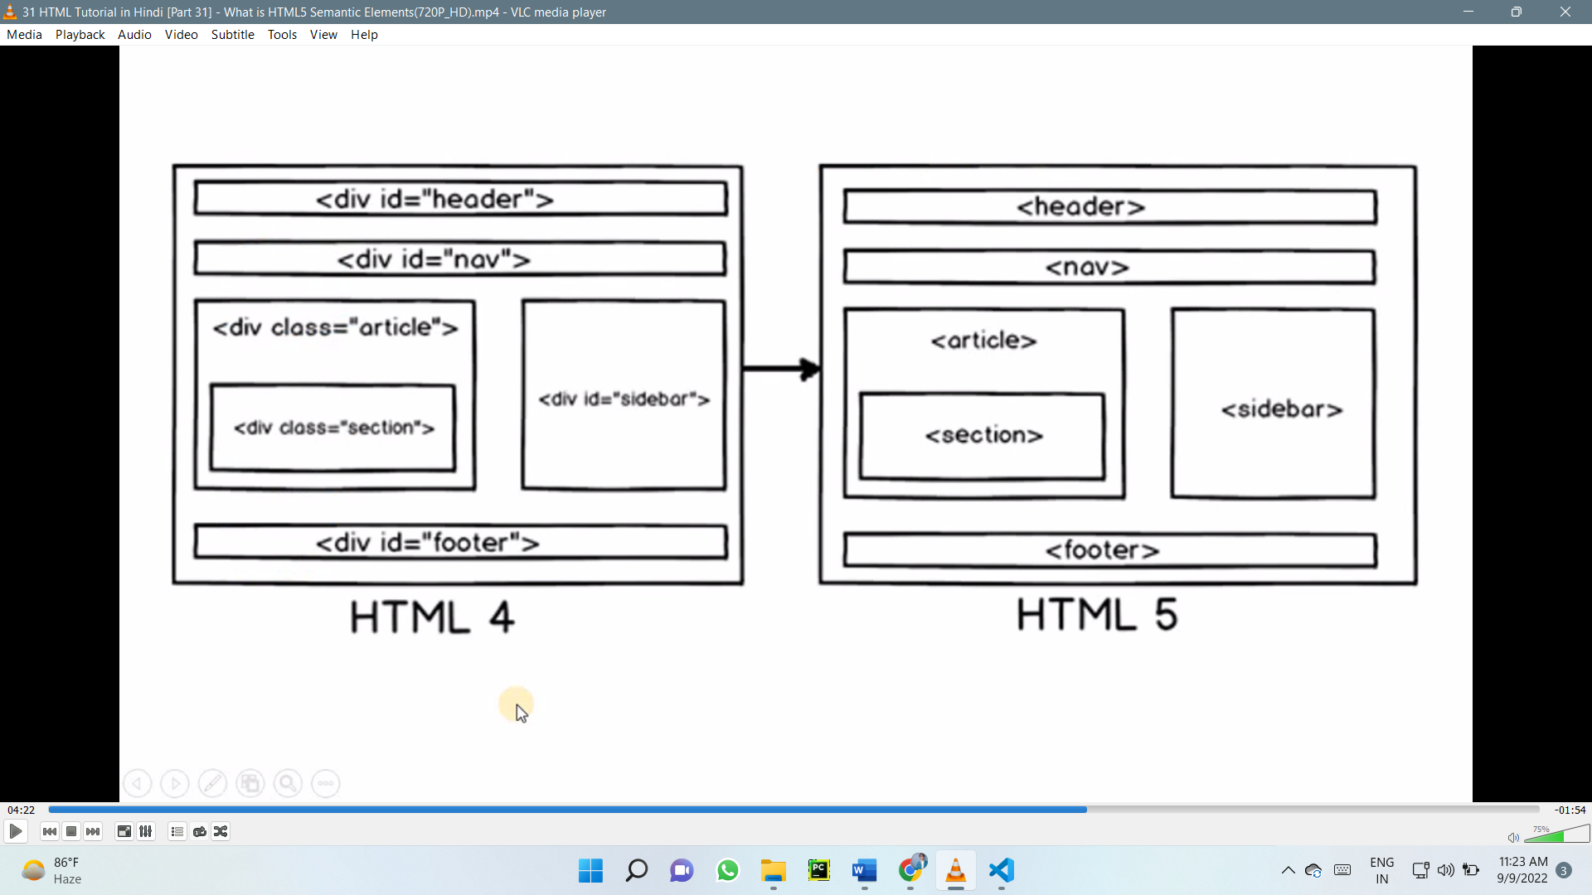

**CODE IN HTML 4 CODE IN HTML 5**

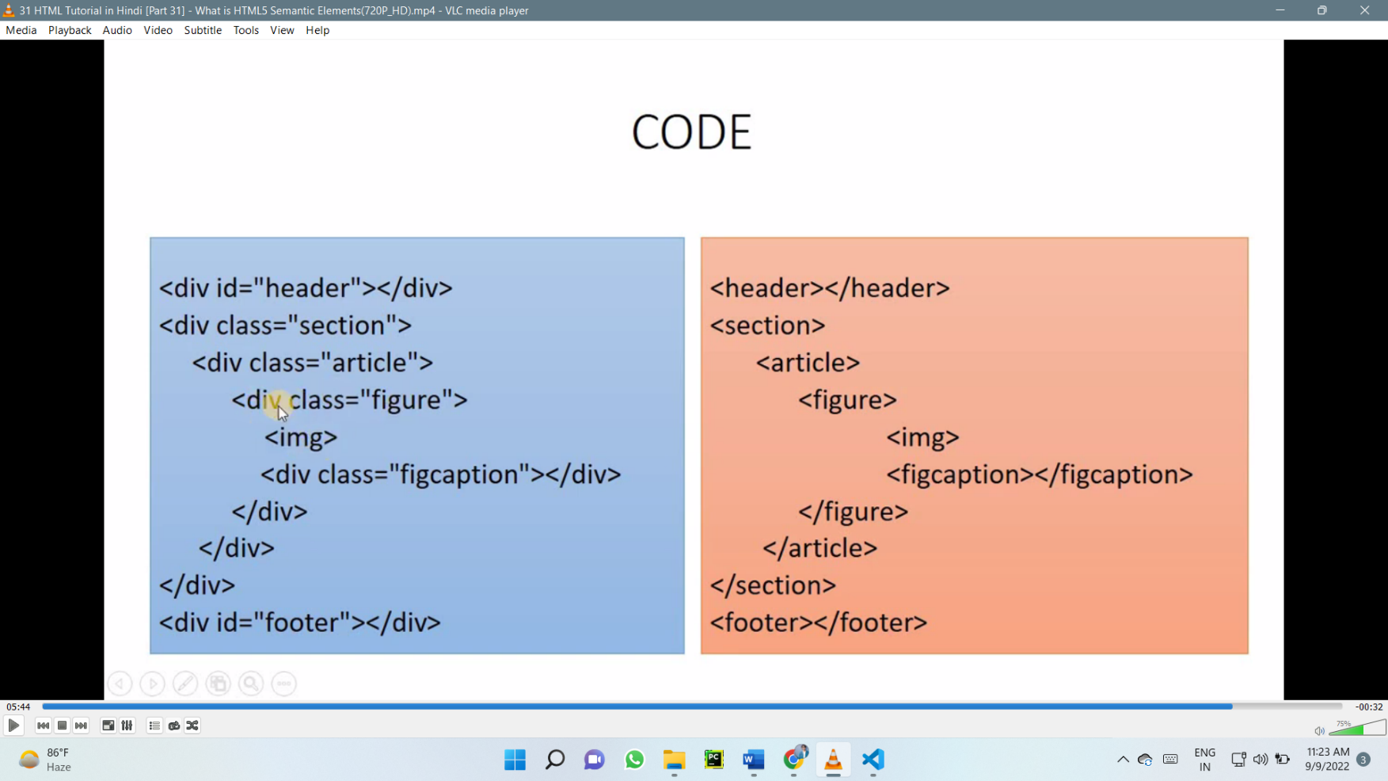

**Semantic Elements in HTML**

Many web sites contain HTML code like: <div id="nav"> <div class="header"> <div id="footer"> to indicate navigation, header, and footer.

In HTML there are some semantic elements that can be used to define different parts of a web page:

<article> <aside> <details> <figcaption> <figure> <footer> <header> <main> <mark> <nav> <section> <summary> <time>

## HTML <section> Element

The <section> element defines a section in a document.

According to W3C's HTML documentation: "A section is a thematic grouping of content, typically with a heading."

Examples of where a <section> element can be used:

* Chapters
* Introduction
* News items
* Contact information

|  |
| --- |
| WWF The World Wide Fund for Nature (WWF). |

A web page could normally be split into sections for introduction, content, and contact information.

|  |
| --- |
| <!DOCTYPE html>  <html>  <body>  <section>  <h1>WWF</h1>  <p>The World Wide  Fund for Nature (WWF)  .</p>  </section>  </body>  </html> |

## HTML <article> Element

The <article> element specifies independent, self-contained content.

An article should make sense on its own, and it should be possible to distribute it independently from the rest of the web site.

Examples of where the <article> element can be used:

* Forum posts
* Blog posts
* User comments
* Product cards
* Newspaper articles

## Nesting <article> in <section> or Vice Versa?

The <article> element specifies independent, self-contained content.

The <section> element defines section in a document.

Can we use the definitions to decide how to nest those elements? No, we cannot!

So, you will find HTML pages with <section> elements containing <article> elements, and <article> elements containing <section> elements.

## HTML <header> Element

The <header> element represents a container for introductory content or a set of navigational links.

A <header> element typically contains:

* one or more heading elements (<h1> - <h6>)
* logo or icon
* authorship information

## HTML <footer> Element

The <footer> element defines a footer for a document or section.

A <footer> element typically contains:

* authorship information
* copyright information
* contact information
* sitemap
* back to top links
* related documents

You can have several <footer> elements in one document.

## HTML <nav> Element

The <nav> element defines a set of navigation links.

## HTML <aside> Element

The <aside> element defines some content aside from the content it is placed in (like a sidebar).

The <aside> content should be indirectly related to the surrounding content.

## HTML <figure> and <figcaption> Elements

The <figure> tag specifies self-contained content, like illustrations, diagrams, photos, code listings, etc.

The <figcaption> tag defines a caption for a <figure> element. The <figcaption> element can be placed as the first or as the last child of a <figure> element.

The <img> element defines the actual image/illustration.

|  |  |
| --- | --- |
| **Tag** | **Description** |
| [<article>](https://www.w3schools.com/tags/tag_article.asp) | Defines independent, self-contained content |
| [<aside>](https://www.w3schools.com/tags/tag_aside.asp) | Defines content aside from the page content |
| [<details>](https://www.w3schools.com/tags/tag_details.asp) | Defines additional details that the user can view or hide |
| [<figcaption>](https://www.w3schools.com/tags/tag_figcaption.asp) | Defines a caption for a <figure> element |
| [<figure>](https://www.w3schools.com/tags/tag_figure.asp) | Specifies self-contained content, like illustrations, diagrams, photos, code listings, etc. |
| [<footer>](https://www.w3schools.com/tags/tag_footer.asp) | Defines a footer for a document or section |
| [<header>](https://www.w3schools.com/tags/tag_header.asp) | Specifies a header for a document or section |
| [<main>](https://www.w3schools.com/tags/tag_main.asp) | Specifies the main content of a document |
| [<mark>](https://www.w3schools.com/tags/tag_mark.asp) | Defines marked/highlighted text |
| [<nav>](https://www.w3schools.com/tags/tag_nav.asp) | Defines navigation links |
| [<section>](https://www.w3schools.com/tags/tag_section.asp) | Defines a section in a document |
| [<summary>](https://www.w3schools.com/tags/tag_summary.asp) | Defines a visible heading for a <details> element |
| [<time>](https://www.w3schools.com/tags/tag_time.asp) | Defines a date/time |

# **Image map**

Go to imagemap.org

Select image map image

Copy and paste in html

# **HTML Forms**

An HTML form is used to collect user input. The user input is most often sent to a server for processing.

<!DOCTYPE html>

<html>

<body>

<h2>HTML Forms</h2>

<form action="/action_page.php">

<label for="fname">First name:</label><br>

<input type="text" id="fname" name="fname" value="John"><br>

<label for="lname">Last name:</label><br>

<input type="text" id="lname" name="lname" value="Doe"><br><br>

<input type="submit" value="Submit">

</form>

<p>If you click the "Submit" button, the form-data will be sent to a page called "/action_page.php".</p>

</body>

</html>

**HTML Forms**

Top of Form

First name:  
  
Last name:  
  
  


Bottom of Form

If you click the "Submit" button, the form-data will be sent to a page called "/action_page.php".

## The <form> Element

The HTML <form> element is used to create an HTML form for user input:

<form>  
.  
*form elements*  
.  
</form>

The <form> element is a container for different types of input elements, such as: text fields, checkboxes, radio buttons, submit buttons, etc.

## The <label> Element

Notice the use of the <label> element in the example above.

The <label> tag defines a label for many form elements.

The <label> element is useful for screen-reader users, because the screen-reader will read out loud the label when the user focus on the input element.

The <label> element also help users who have difficulty clicking on very small regions (such as radio buttons or checkboxes) - because when the user clicks the text within the <label> element, it toggles the radio button/checkbox.

The for attribute of the <label> tag should be equal to the id attribute of the <input> element to bind them together

## HTML Form Attributes

### The Action Attribute

The action attribute defines the action to be performed when the form is submitted.

Usually, the form data is sent to a file on the server when the user clicks on the submit button.

In the example below, the form data is sent to a file called "action_page.php". This file contains a server-side script that handles the form data:

On submit, send form data to "action_page.php":

<form action="/action_page.php">  
  <label for="fname">First name:</label><br>  
  <input type="text" id="fname" name="fname" value="John"><br>  
  <label for="lname">Last name:</label><br>  
  <input type="text" id="lname" name="lname" value="Doe"><br><br>  
  <input type="submit" value="Submit">  
</form>

### The Target Attribute

|  |  |
| --- | --- |
| **Value** | **Description** |
| _blank | The response is displayed in a new window or tab |
| _self | The response is displayed in the current window |
| _parent | The response is displayed in the parent frame |
| _top | The response is displayed in the full body of the window |
| *framename* | The response is displayed in a named iframe |

The target attribute specifies where to display the response that is received after submitting the form.

The target attribute can have one of the following values:

The default value is _self which means that the response will open in the current window.

Here, the submitted result will open in a new browser tab:

<form action="/action_page.php" target="_blank">

### The Method Attribute

The method attribute specifies the HTTP method to be used when submitting the form data.

The form-data can be sent as URL variables (with method="get") or as HTTP post transaction (with method="post").

The default HTTP method when submitting form data is GET.

**Example**

This example uses the GET method when submitting the form data:

<form action="/action_page.php" method="get">

**Example**

This example uses the POST method when submitting the form data:

<form action="/action_page.php" method="post">

**Notes on GET:**

Appends the form data to the URL, in name/value pairs

NEVER use GET to send sensitive data! (the submitted form data is visible in the URL!)

The length of a URL is limited (2048 characters)

Useful for form submissions where a user wants to bookmark the result

GET is good for non-secure data, like query strings in Google

**Notes on POST:**

Appends the form data inside the body of the HTTP request (the submitted form data is not shown in the URL)

POST has no size limitations, and can be used to send large amounts of data.

Form submissions with POST cannot be bookmarked

Tip: Always use POST if the form data contains sensitive or personal information!

**The Autocomplete Attribute**

The autocomplete attribute specifies whether a form should have autocomplete on or off.

When autocomplete is on, the browser automatically complete values based on values that the user has entered before.

**Example**

A form with autocomplete on:

<form action="/action_page.php" autocomplete="on">

**The Novalidate Attribute**

The novalidate attribute is a boolean attribute.

The novalidate attribute indicates that the form input is not to be validated on submit:

**Example**

A form with a novalidate attribute:

<form action="/action_page.php" novalidate>

## The HTML <form> Elements

The HTML <form> element can contain one or more of the following form elements

|  |  |
| --- | --- |
| **Tag** | **Description** |
| [<form>](https://www.w3schools.com/tags/tag_form.asp) | Defines an HTML form for user input |
| [<input>](https://www.w3schools.com/tags/tag_input.asp) | Defines an input control |
| [<textarea>](https://www.w3schools.com/tags/tag_textarea.asp) | Defines a multiline input control (text area) |
| [<label>](https://www.w3schools.com/tags/tag_label.asp) | Defines a label for an <input> element |
| [<fieldset>](https://www.w3schools.com/tags/tag_fieldset.asp) | Groups related elements in a form |
| [<legend>](https://www.w3schools.com/tags/tag_legend.asp) | Defines a caption for a <fieldset> element |
| [<select>](https://www.w3schools.com/tags/tag_select.asp) | Defines a drop-down list |
| [<optgroup>](https://www.w3schools.com/tags/tag_optgroup.asp) | Defines a group of related options in a drop-down list |
| [<option>](https://www.w3schools.com/tags/tag_option.asp) | Defines an option in a drop-down list |
| [<button>](https://www.w3schools.com/tags/tag_button.asp) | Defines a clickable button |
| [<datalist>](https://www.w3schools.com/tags/tag_datalist.asp) | Specifies a list of pre-defined options for input controls |
| [<output>](https://www.w3schools.com/tags/tag_output.asp) | Defines the result of a calculation |

### The <input> Element

One of the most used form element is the <input> element.

The <input> element can be displayed in several ways, depending on the type attribute.

<form action="/action_page.php">

<label for="fname">First name:</label><br>

<input type="text" id="fname" name="fname"><br><br>

<input type="submit" value="Submit">

</form>

Output -

The input Element

Top of Form

First name:  
  
  


Bottom of Form

### The <select> Element

The <select> element defines a drop-down list:

The <option> elements defines an option that can be selected.

By default, the first item in the drop-down list is selected.

To define a pre-selected option, add the selected attribute to the option:

<form action="/action_page.php">

<label for="cars">Choose a car:</label>

<select id="cars" name="cars">

<option value="volvo">Volvo</option>

<option value="saab">Saab</option>

<option value="fiat" selected>Fiat</option>

<option value="audi">Audi</option>

</select>

<input type="submit">

</form>

Output –

Pre-selected Option

You can preselect an option with the selected attribute:

Top of Form

Choose a car:                    

#### **Visible Values:**

Use the size attribute to specify the number of visible values:

<label for="cars">Choose a car:</label>  
<select id="cars" name="cars" size="3">  
  <option value="volvo">Volvo</option>  
  <option value="saab">Saab</option>  
  <option value="fiat">Fiat</option>  
  <option value="audi">Audi</option>  
</select>

#### **Allow Multiple Selections:**

Use the multiple attribute to allow the user to select more than one value:

<label for="cars">Choose a car:</label>  
<select id="cars" name="cars" size="4" multiple>  
  <option value="volvo">Volvo</option>  
  <option value="saab">Saab</option>  
  <option value="fiat">Fiat</option>  
  <option value="audi">Audi</option>  
</select>

### The <textarea> Element

The <textarea> element defines a multi-line input field (a text area):

<form action="/action_page.php">

<textarea name="message" rows="10" cols="30">The cat was playing in the garden.</textarea>

<br><br>

<input type="submit">

Output –

textarea

The textarea element defines a multi-line input field.

Top of Form

  
  


Bottom of Form

### The <button> Element

The <button> element defines a clickable button:

<button type="button" onclick="alert('Hello World!')">Click Me!</button>

Output –

button

Click Me!

</form>Bottom of Form

When you click on click me , it will show hello world

### The <fieldset> and <legend> Elements

The <fieldset> element is used to group related data in a form.

The <legend> element defines a caption for the <fieldset> element.

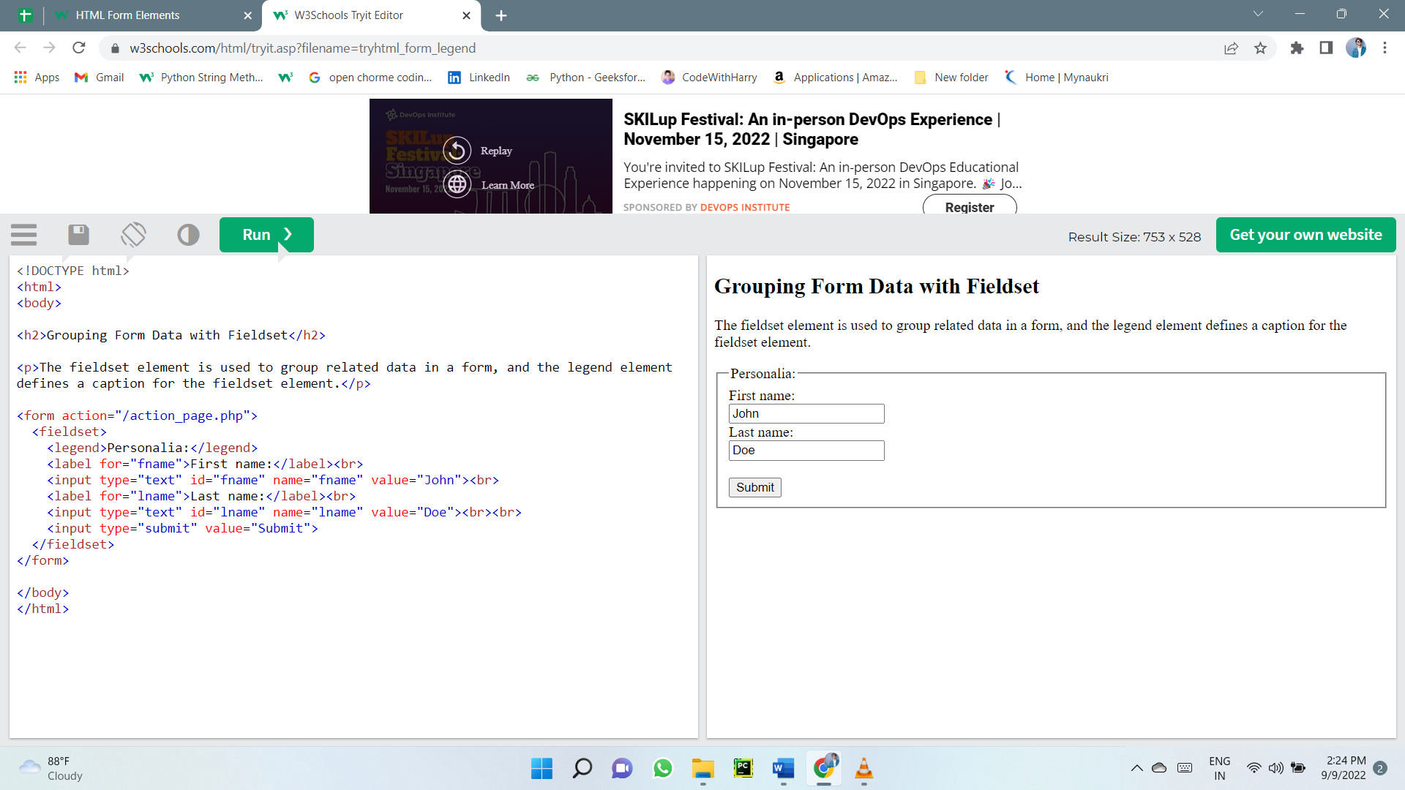

### The <datalist> Element

The <datalist> element specifies a list of pre-defined options for an <input> element.

Users will see a drop-down list of the pre-defined options as they input data.

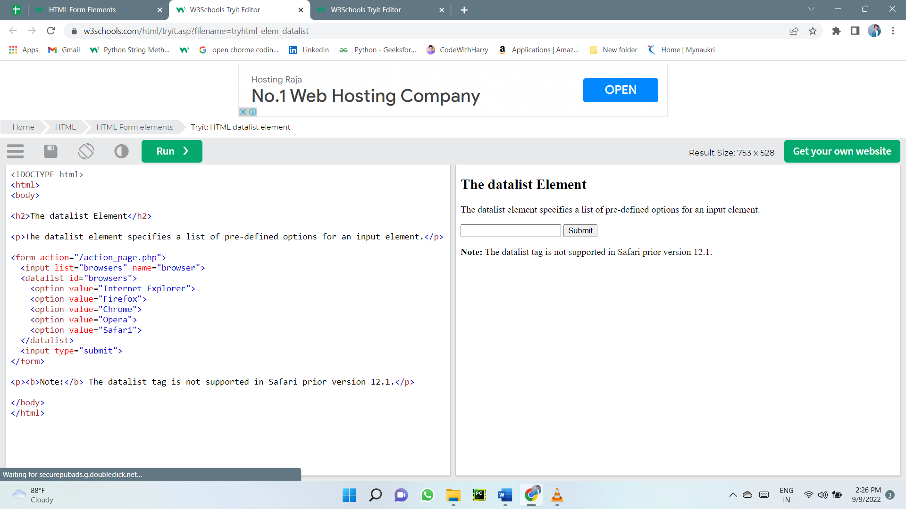The list attribute of the <input> element, must refer to the id attribute of the <datalist> element.

## HTML Input Types

Here are the different input types you can use in HTML:

* <input type="button">
* <input type="checkbox">
* <input type="color">
* <input type="date">
* <input type="datetime-local">
* <input type="email">
* <input type="file">
* <input type="hidden">
* <input type="image">
* <input type="month">
* <input type="number">
* <input type="password">
* <input type="radio">
* <input type="range">
* <input type="reset">
* <input type="search">
* <input type="submit">
* <input type="tel">
* <input type="text">
* <input type="time">
* <input type="url">
* <input type="week">

Tip: The default value of the type attribute is "text".

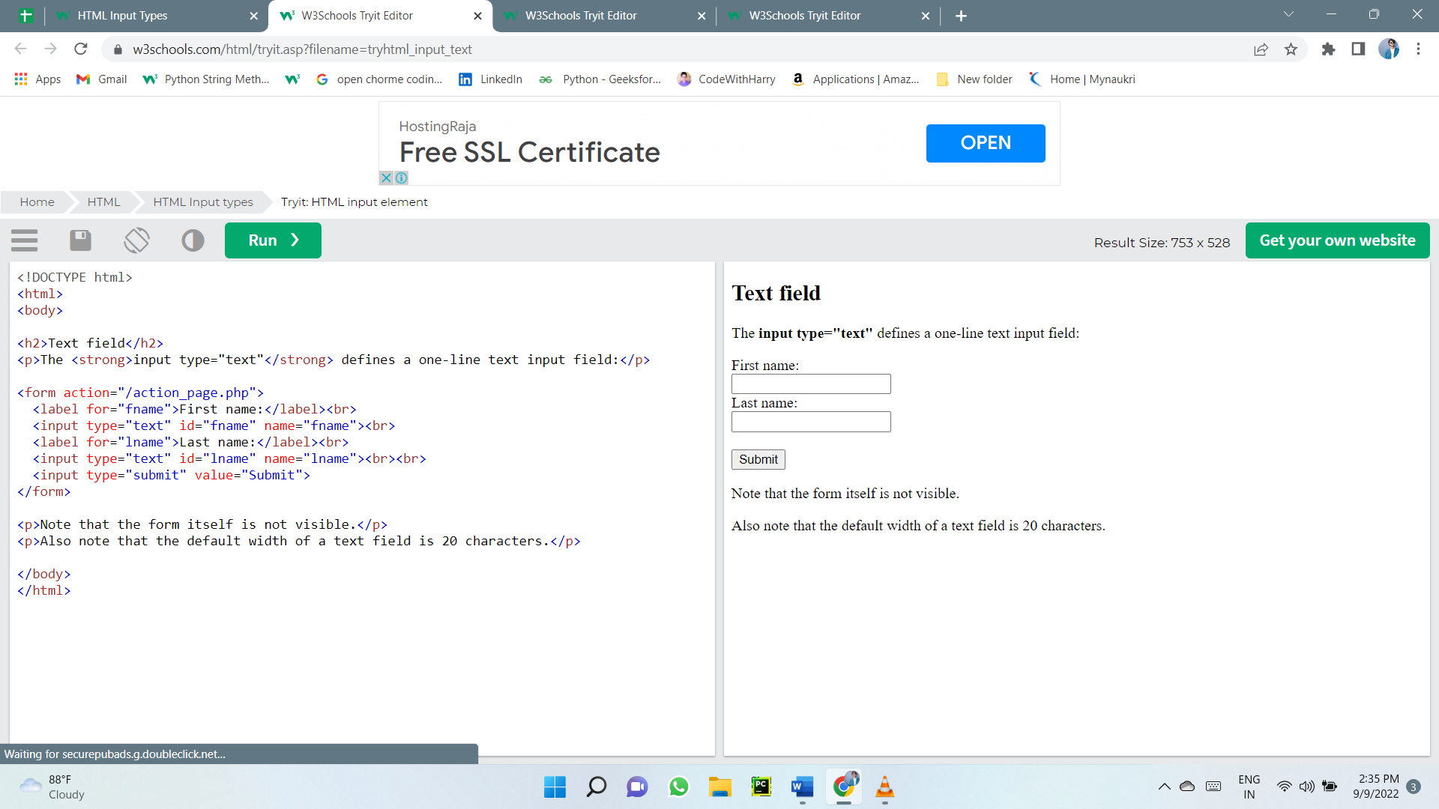

### Input Type Password

<input type="password"> defines a password field

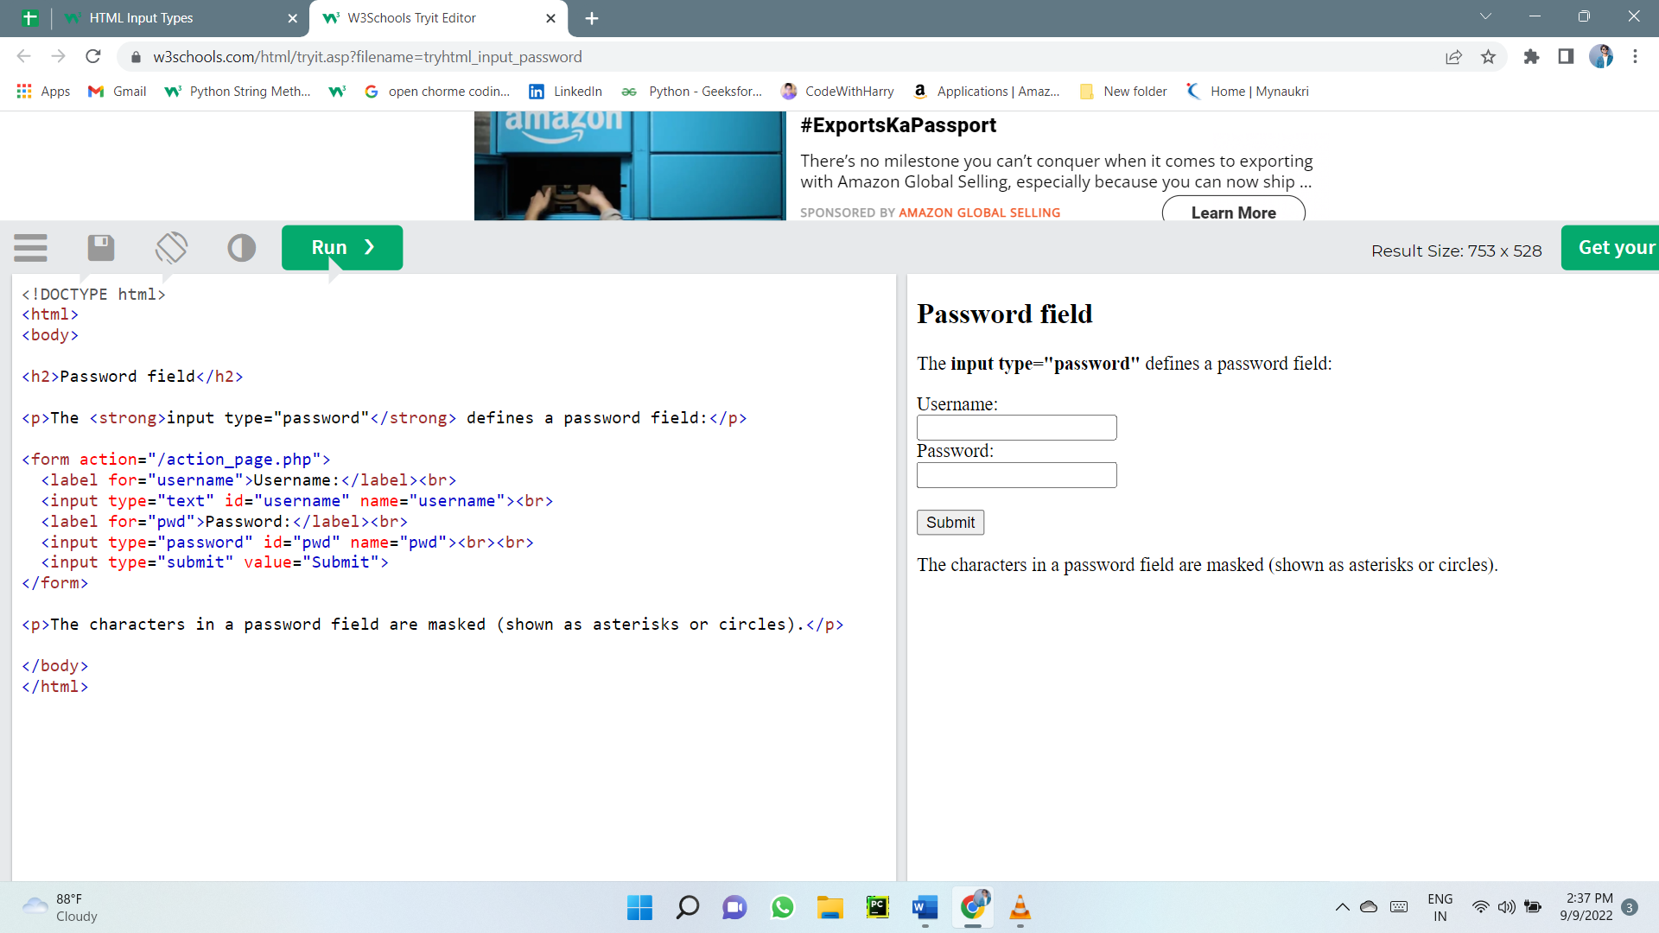

### Input Type Submit

<input type="submit"> defines a button for submitting form data to a form-handler.

The form-handler is typically a server page with a script for processing input data.

The form-handler is specified in the form's action attribute:

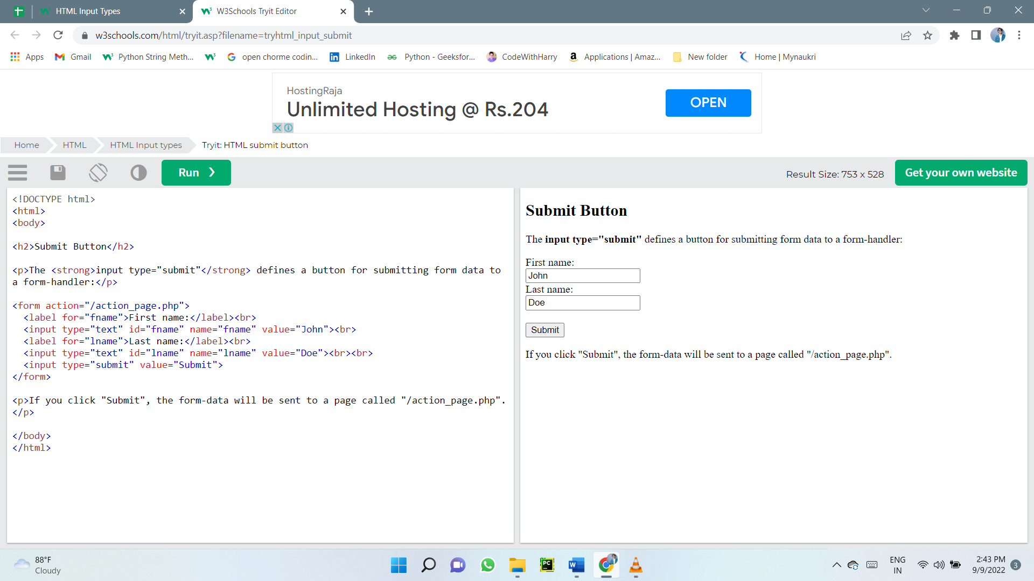

### Input Type Reset

<input type="reset"> defines a reset button that will reset all form values to their default values:

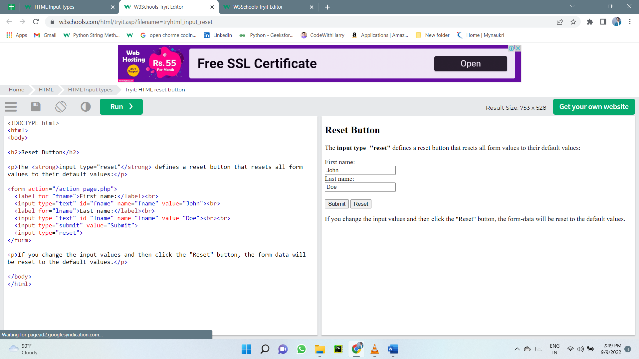

### Input Type Radio

<input type="radio"> defines a radio button.

Radio buttons let a user select ONLY ONE of a limited number of choices:

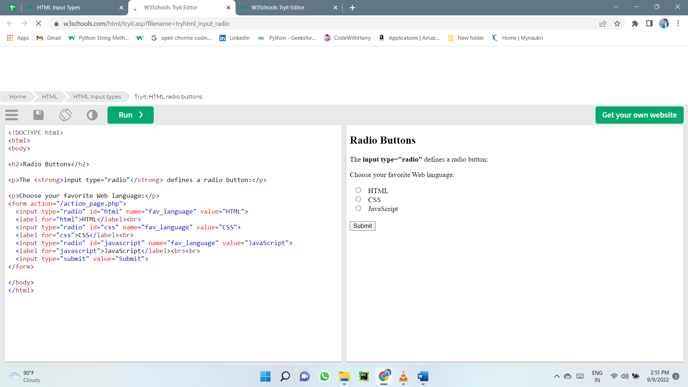

### Input Type Checkbox

<input type="checkbox"> defines a checkbox.

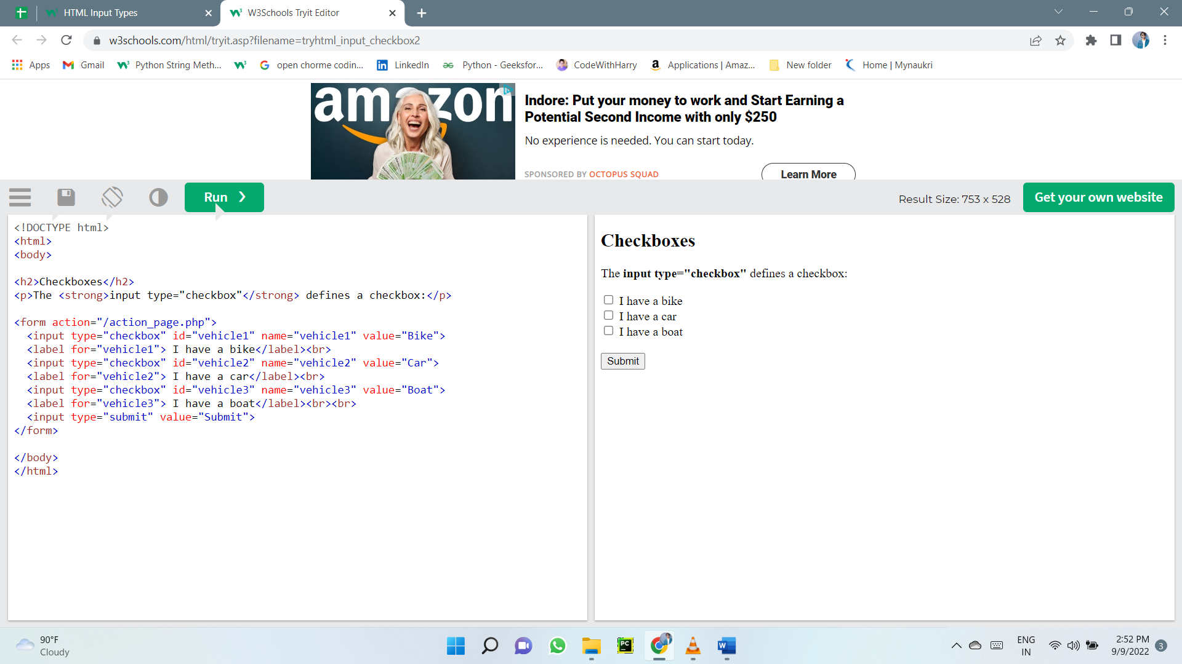Checkboxes let a user select ZERO or MORE options of a limited number of choices.

### Input Type Button

<input type="button"> defines a button:

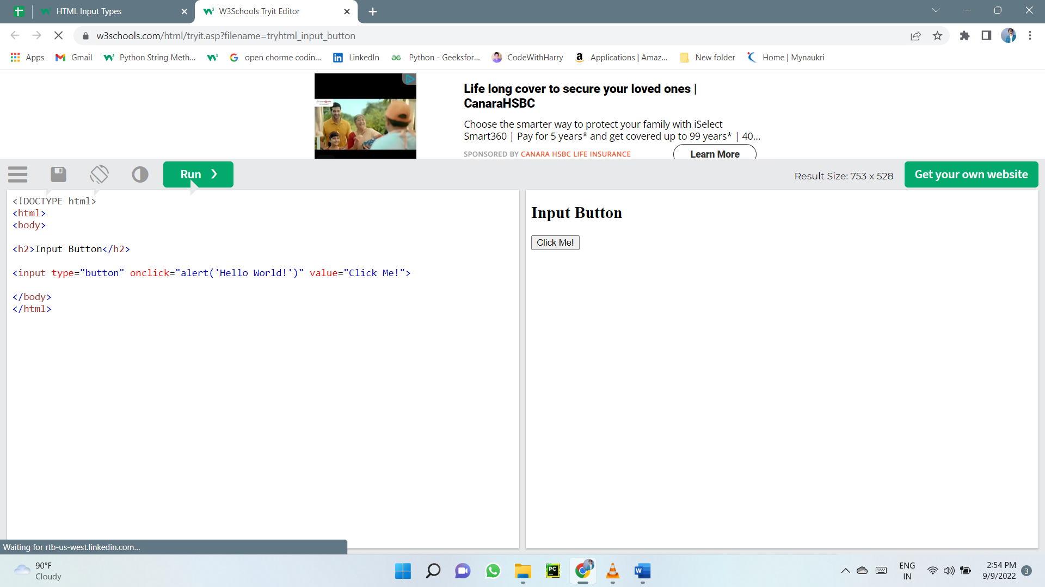

### Input Type Color

The <input type="color"> is used for input fields that should contain a color.

Depending on browser support, a color picker can show up in the input field.

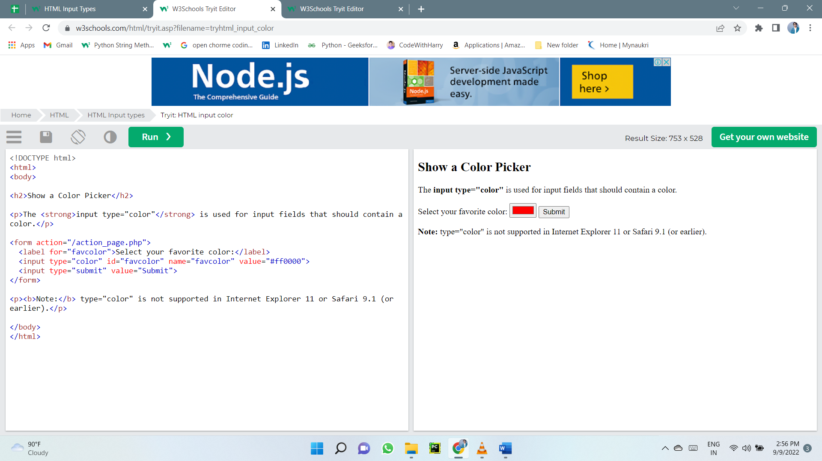

### Input Type Date

The <input type="date"> is used for input fields that should contain a date.

Depending on browser support, a date picker can show up in the input field.

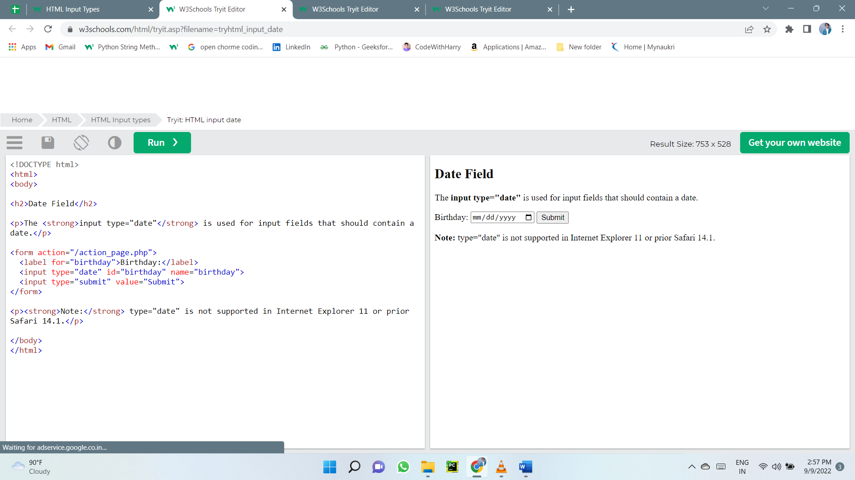

### Input Type Datetime-local

The <input type="datetime-local"> specifies a date and time input field, with no time zone.

Depending on browser support, a date picker can show up in the input field.

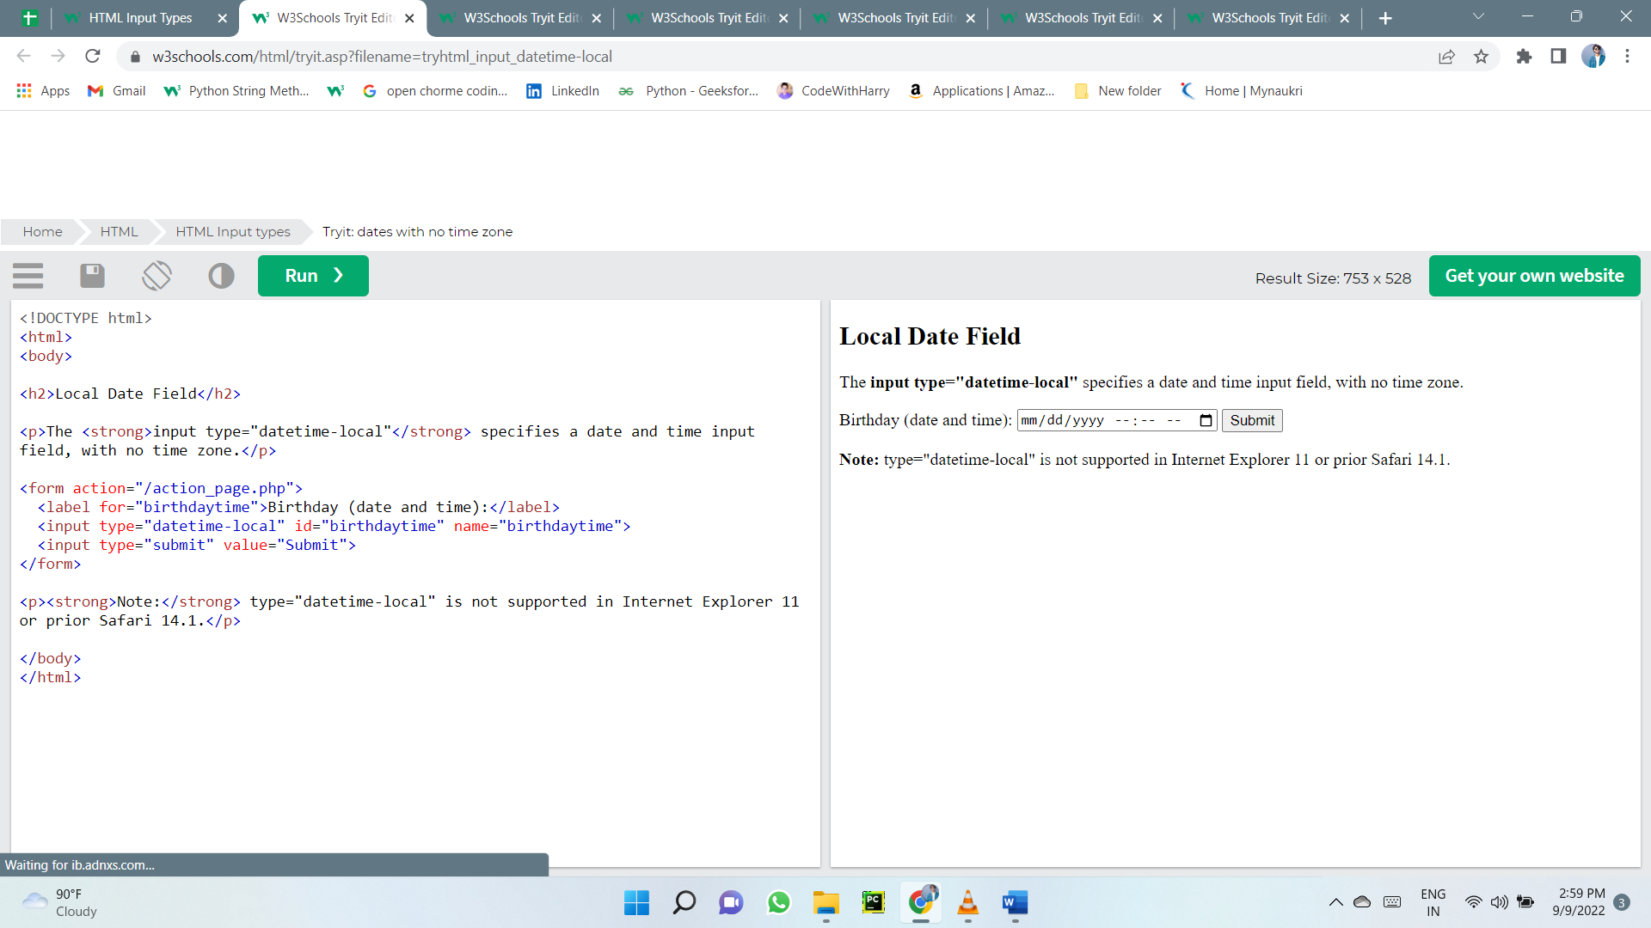

### Input Type Email

The <input type="email"> is used for input fields that should contain an e-mail address.

Depending on browser support, the e-mail address can be automatically validated when submitted.

Some smartphones recognize the email type, and add ".com" to the keyboard to match email input.

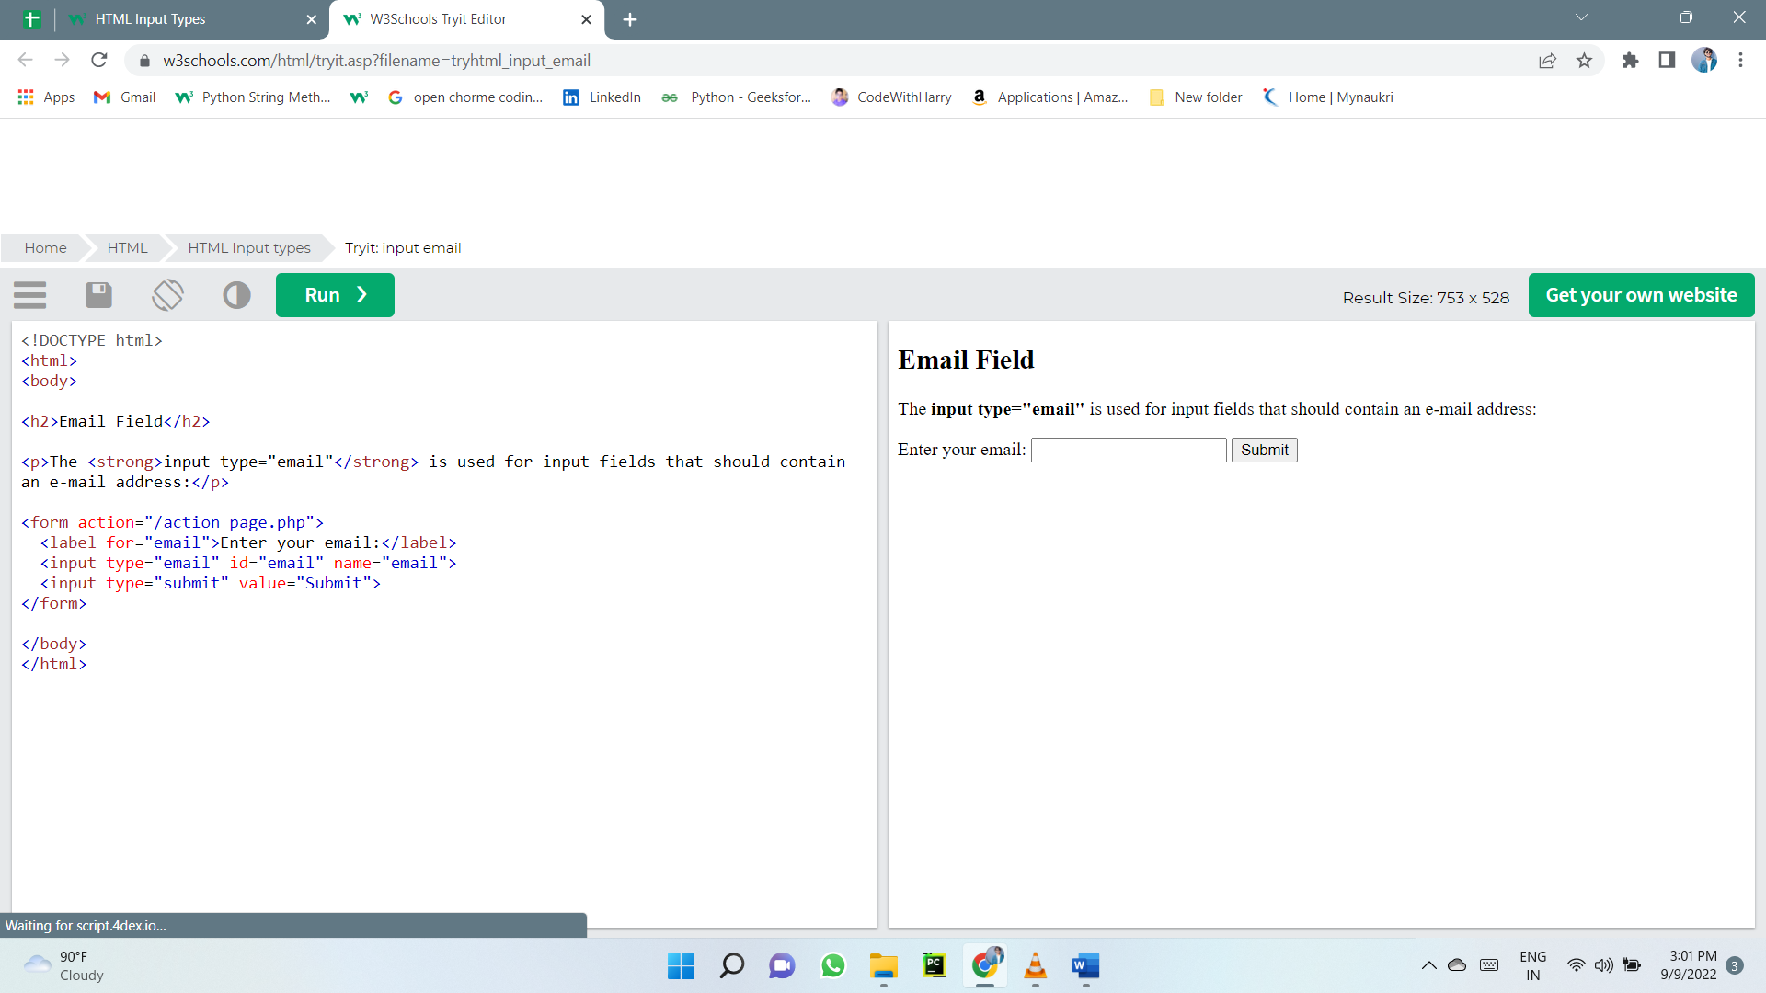

### Input Type Image

The <input type="image"> defines an image as a submit button.

The path to the image is specified in the src attribute.

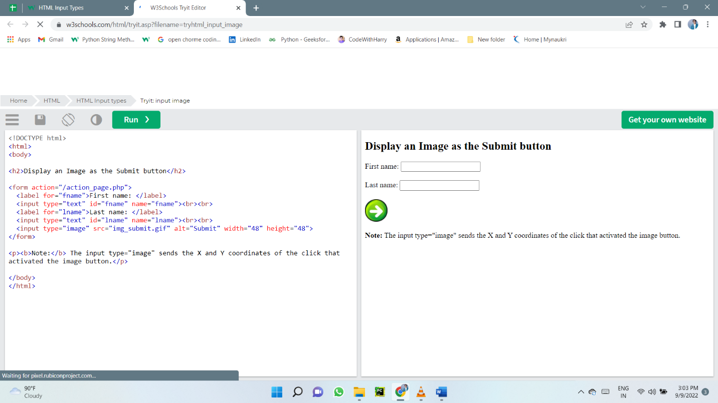

### Input Type File

The <input type="file"> defines a file-select field and a "Browse" button for file uploads.

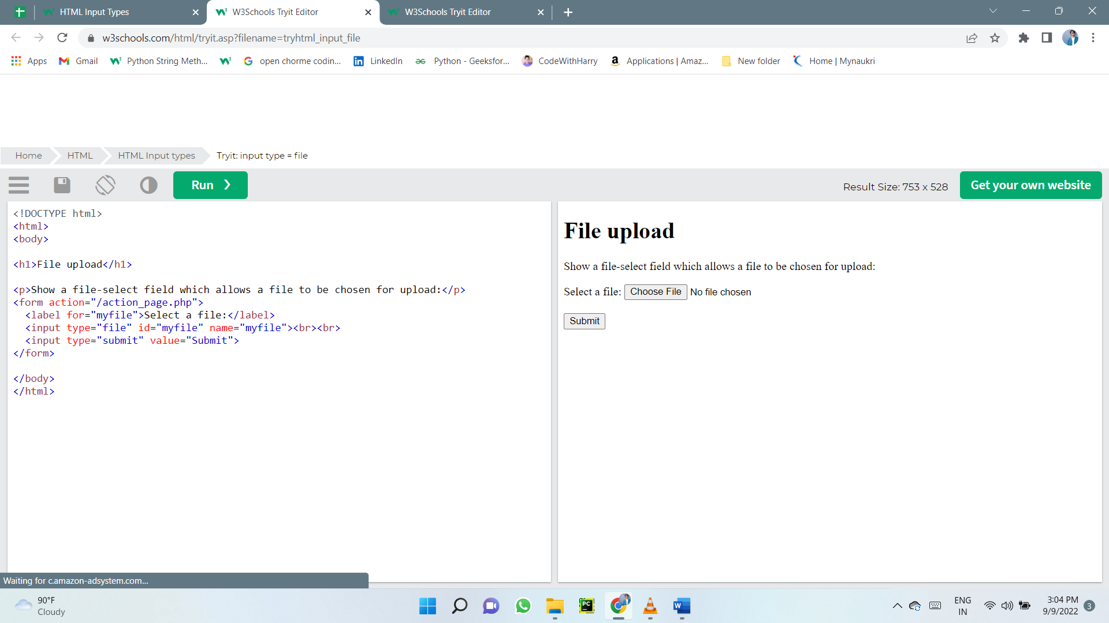

### Input Type Hidden

The <input type="hidden"> defines a hidden input field (not visible to a user).

A hidden field lets web developers include data that cannot be seen or modified by users when a form is submitted.

A hidden field often stores what database record that needs to be updated when the form is submitted.

Note: While the value is not displayed to the user in the page's content, it is visible (and can be edited) using any browser's developer tools or "View Source" functionality. Do not use hidden inputs as a form of security!

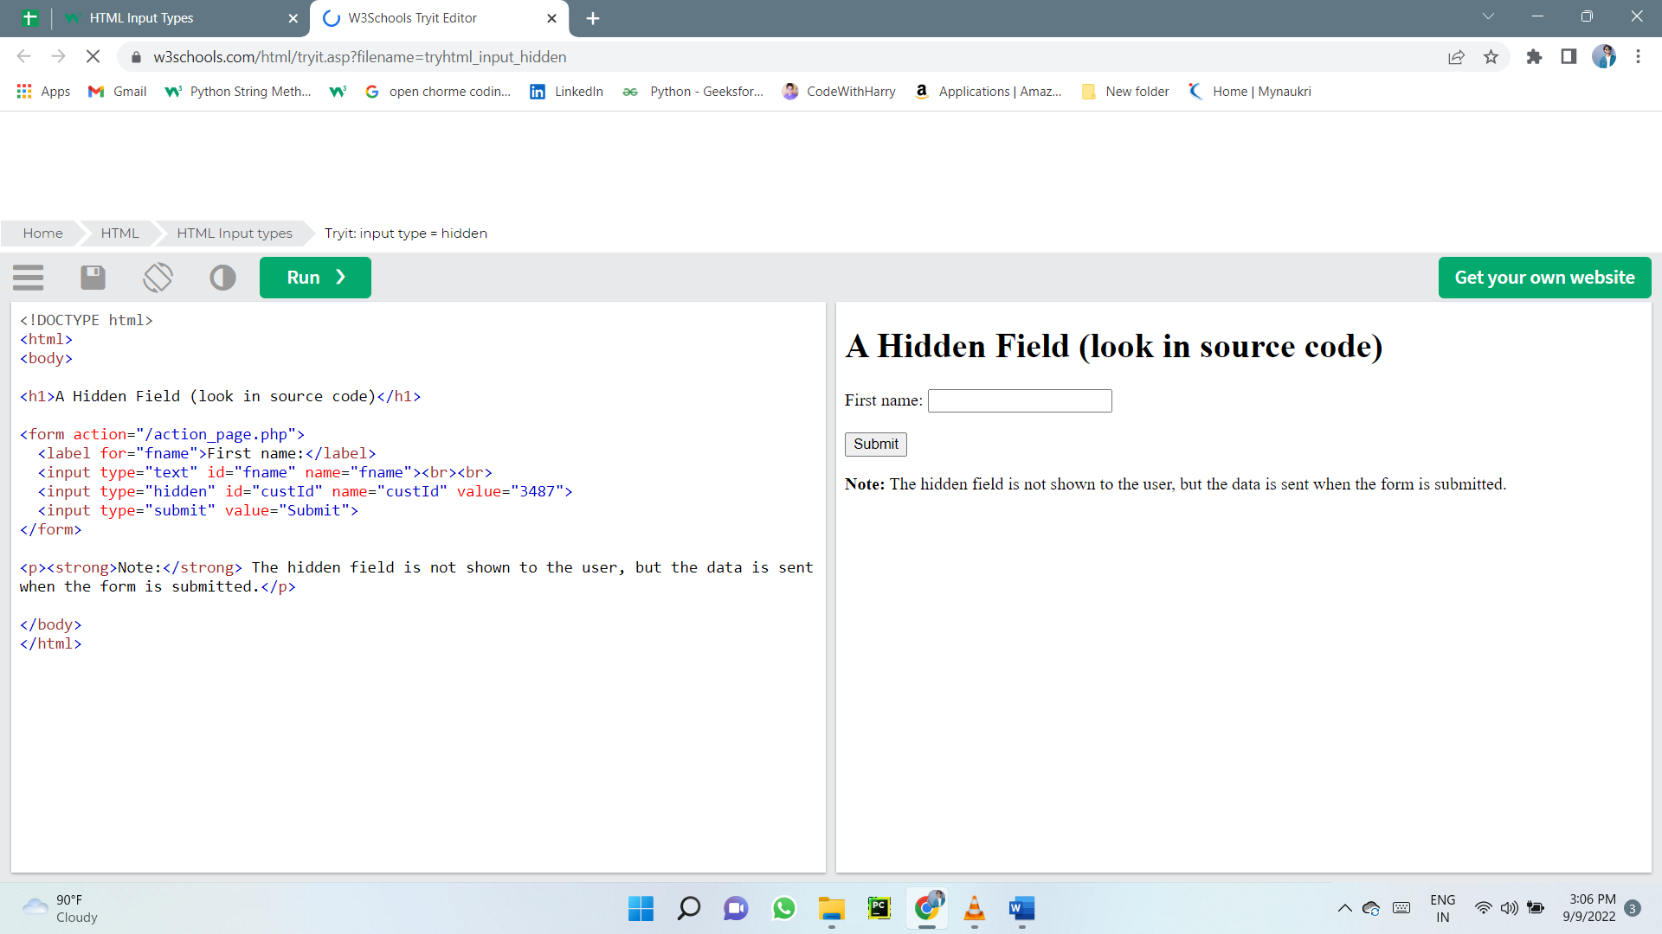

### Input Type Month

The <input type="month"> allows the user to select a month and year.

Depending on browser support, a date picker can show up in the input field.

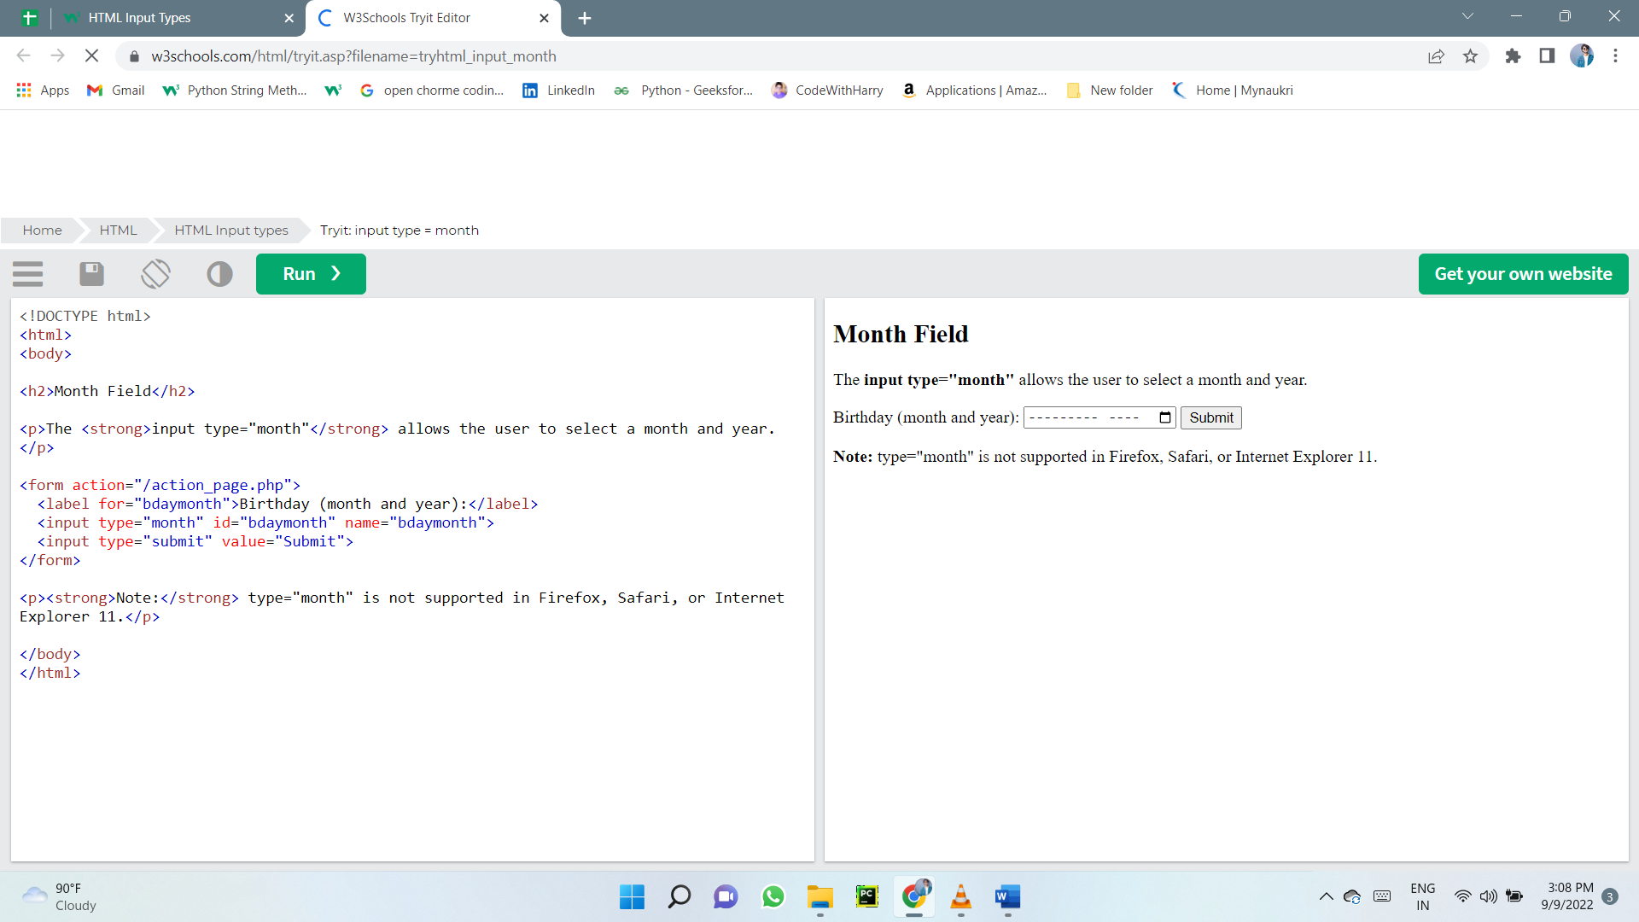

### Input Type Number

The <input type="number"> defines a numeric input field.

You can also set restrictions on what numbers are accepted.

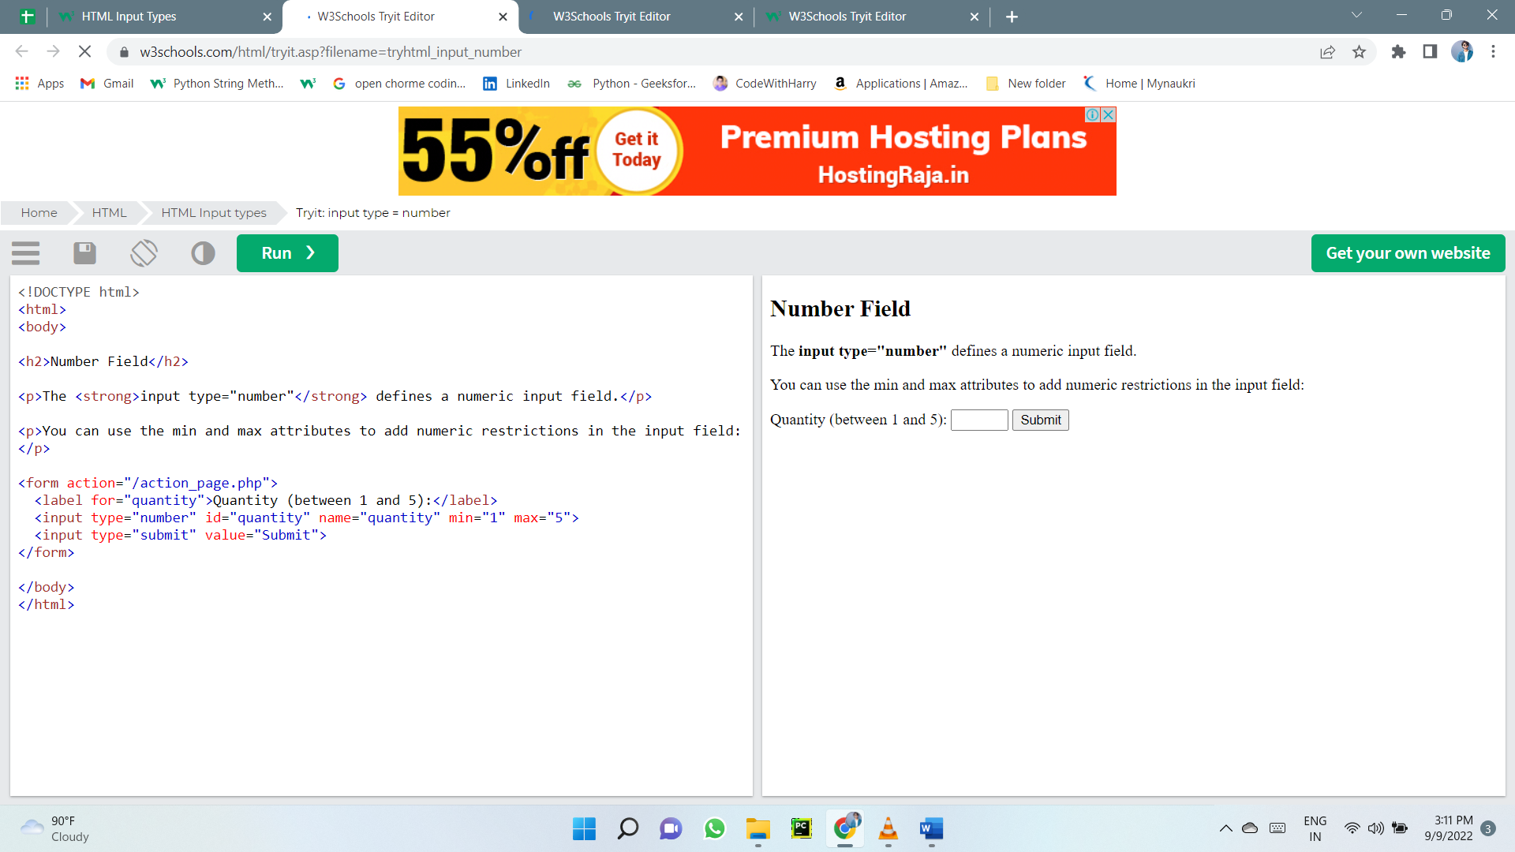The following example displays a numeric input field, where you can enter a value from 1 to 5:

**Input Restrictions**

Here is a list of some common input restrictions:

|  |  |
| --- | --- |
| **Attribute** | **Description** |
| checked | Specifies that an input field should be pre-selected  when the page loads (for type="checkbox" or type="radio") |
| disabled | Specifies that an input field should be disabled |
| max | Specifies the maximum value for an input field |
| maxlength | Specifies the maximum number of character for an input field |
| min | Specifies the minimum value for an input field |
| pattern | Specifies a regular expression to check the input value against |
| readonly | Specifies that an input field is read only (cannot be changed) |
| required | Specifies that an input field is required (must be filled out) |
| size | Specifies the width (in characters) of an input field |
| step | Specifies the legal number intervals for an input field |
| value | Specifies the default value for an input field |

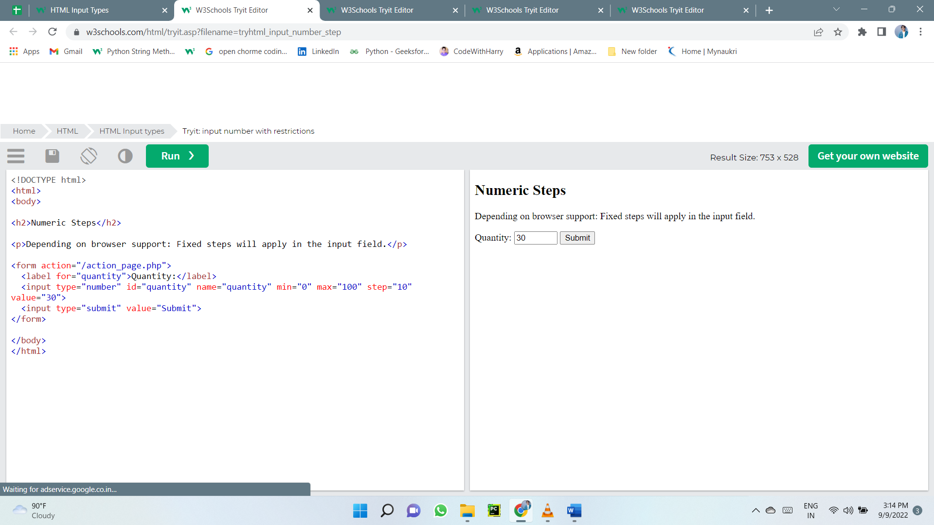

### Input Type Range

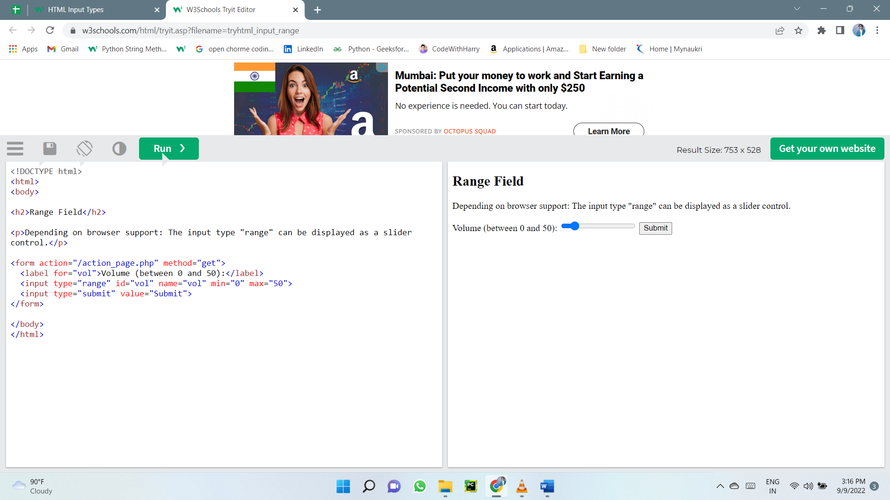The <input type="range"> defines a control for entering a number whose exact value is not important (like a slider control). Default range is 0 to 100. However, you can set restrictions on what numbers are accepted with the min, max, and step attributes

### Input Type Search

The <input type="search"> is used for search fields (a search field behaves like a regular text field).

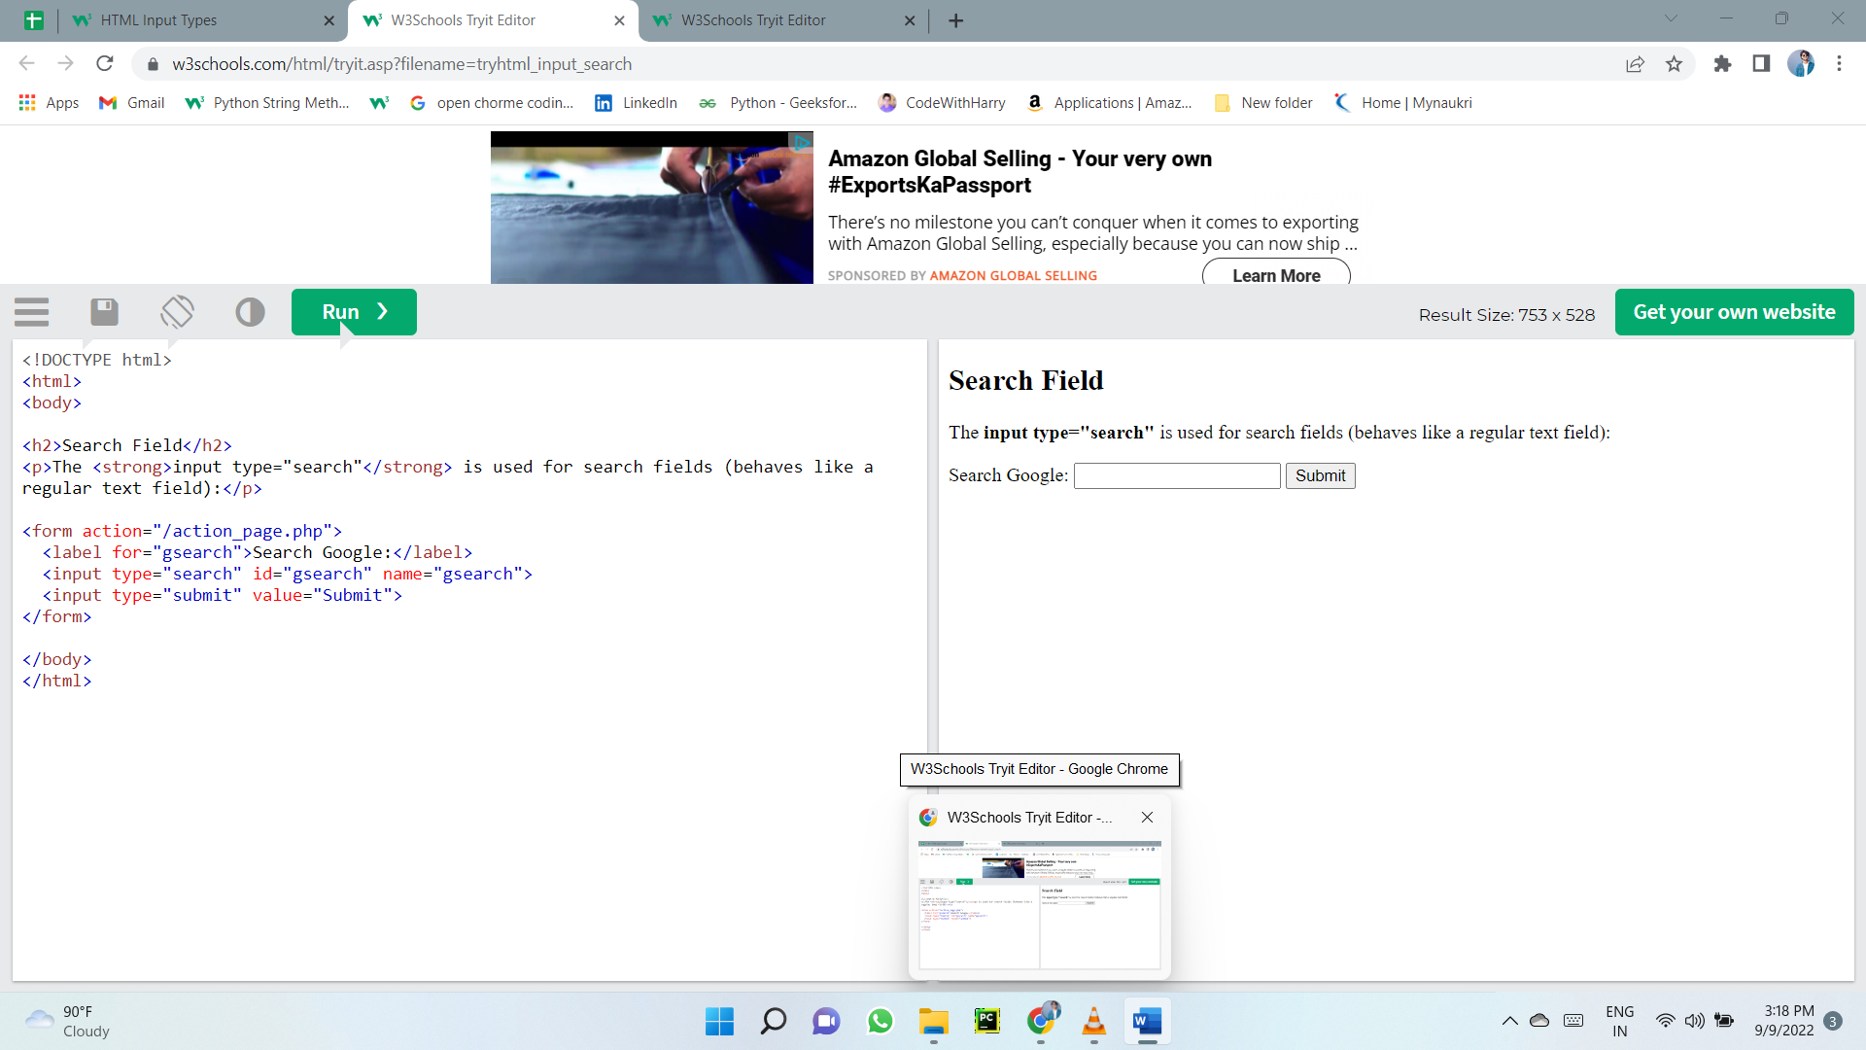

### Input Type Tel

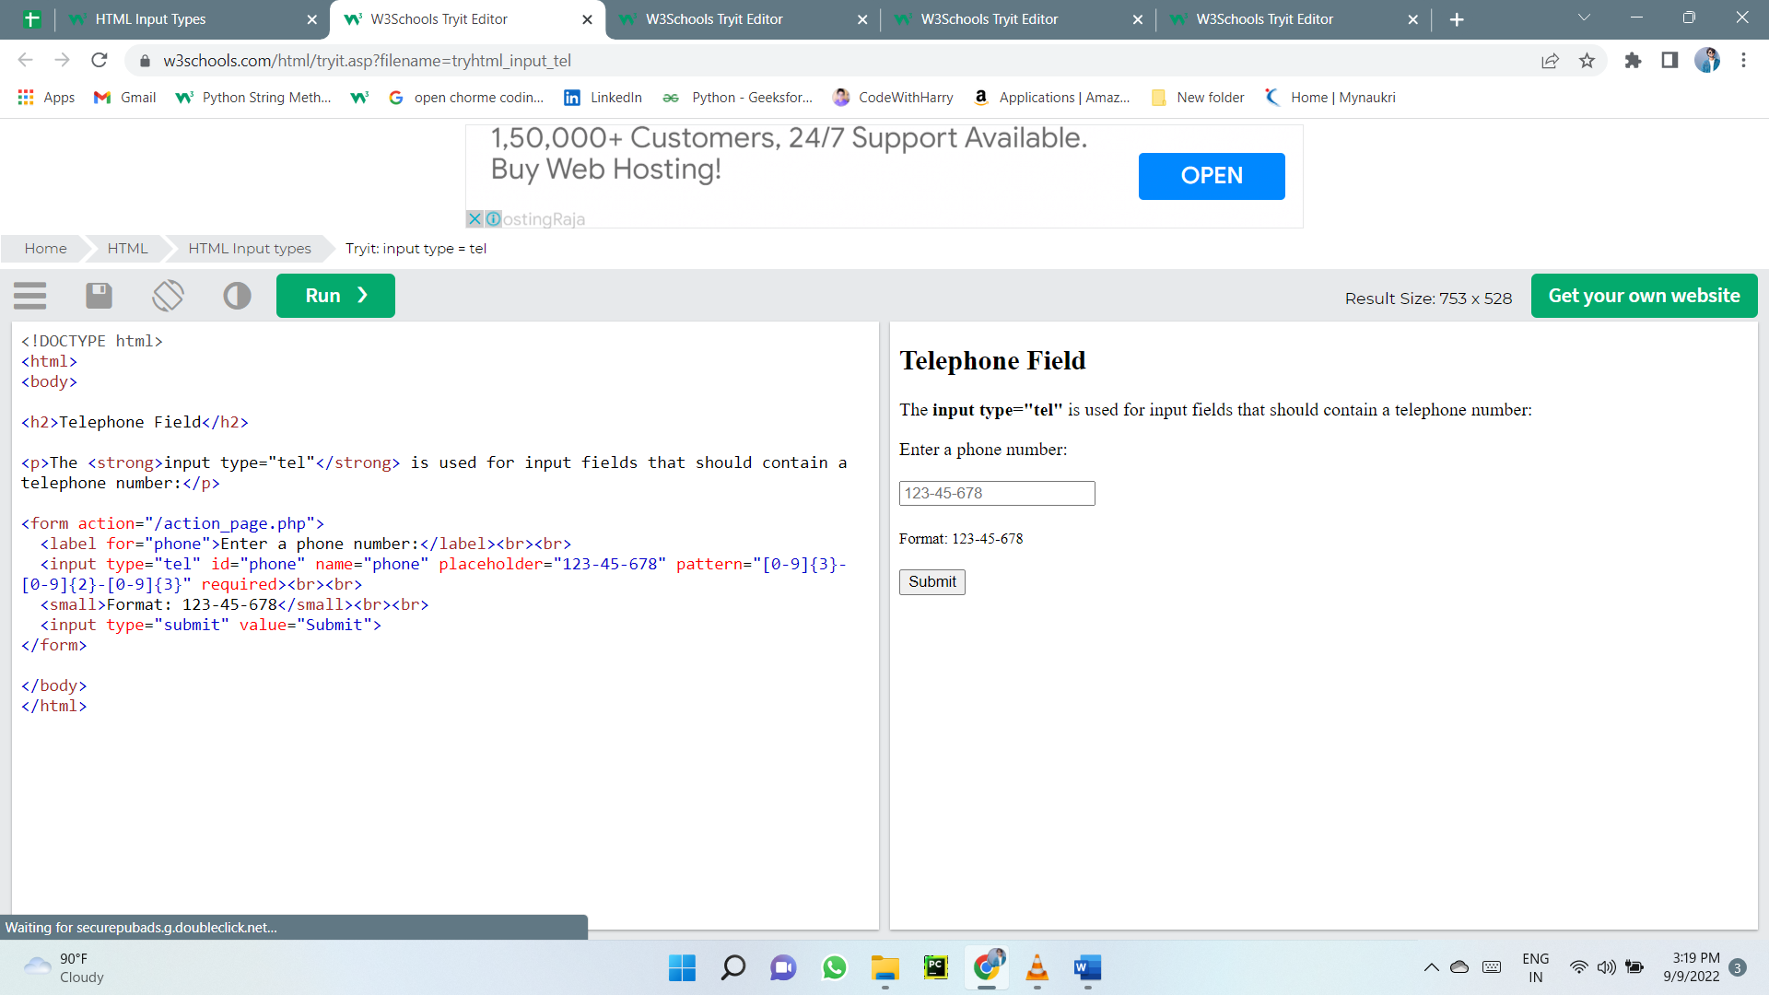The <input type="tel"> is used for input fields that should contain a telephone number.

### Input Type Time

The <input type="time"> allows the user to select a time (no time zone).

Depending on browser support, a time picker can show up in the input field.

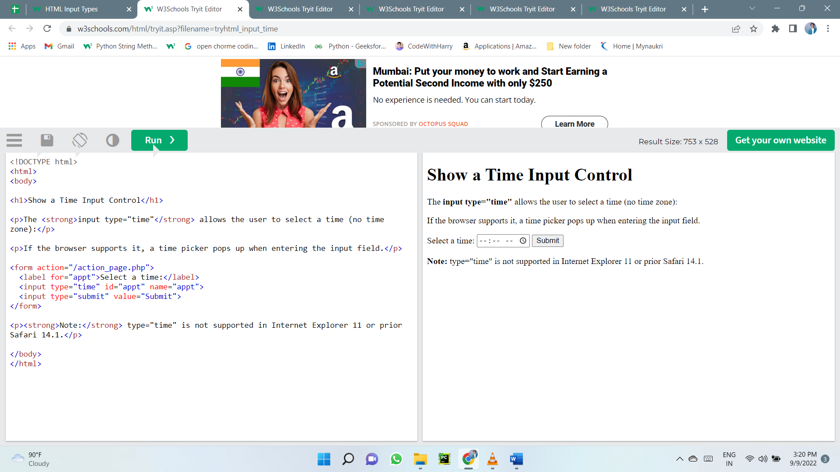

### Input Type Url

The <input type="url"> is used for input fields that should contain a URL address.

Depending on browser support, the url field can be automatically validated when submitted.

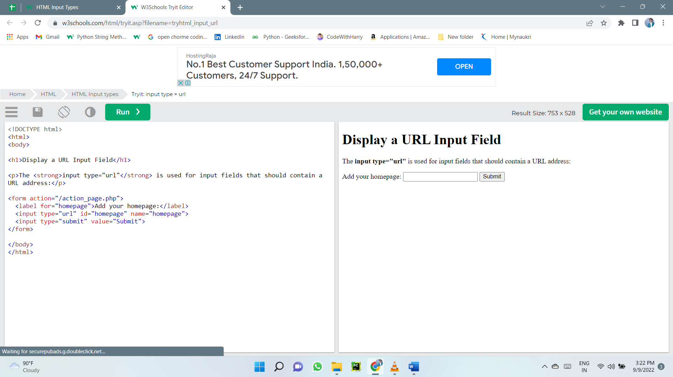Some smartphones recognize the url type, and adds ".com" to the keyboard to match url input.

### Input Type Week

The <input type="week"> allows the user to select a week and year.

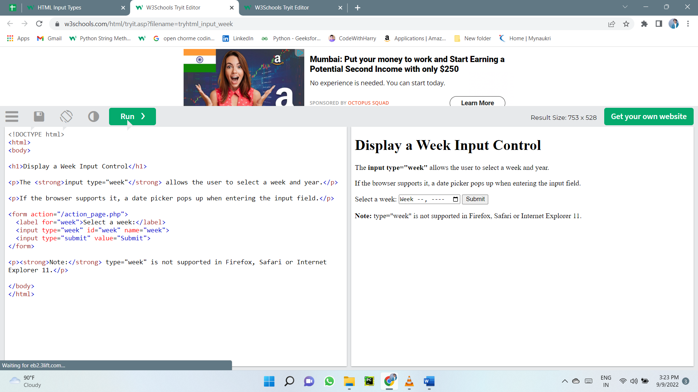Depending on browser support, a date picker can show up in the input field.

## HTML Input Attributes

### The value Attribute

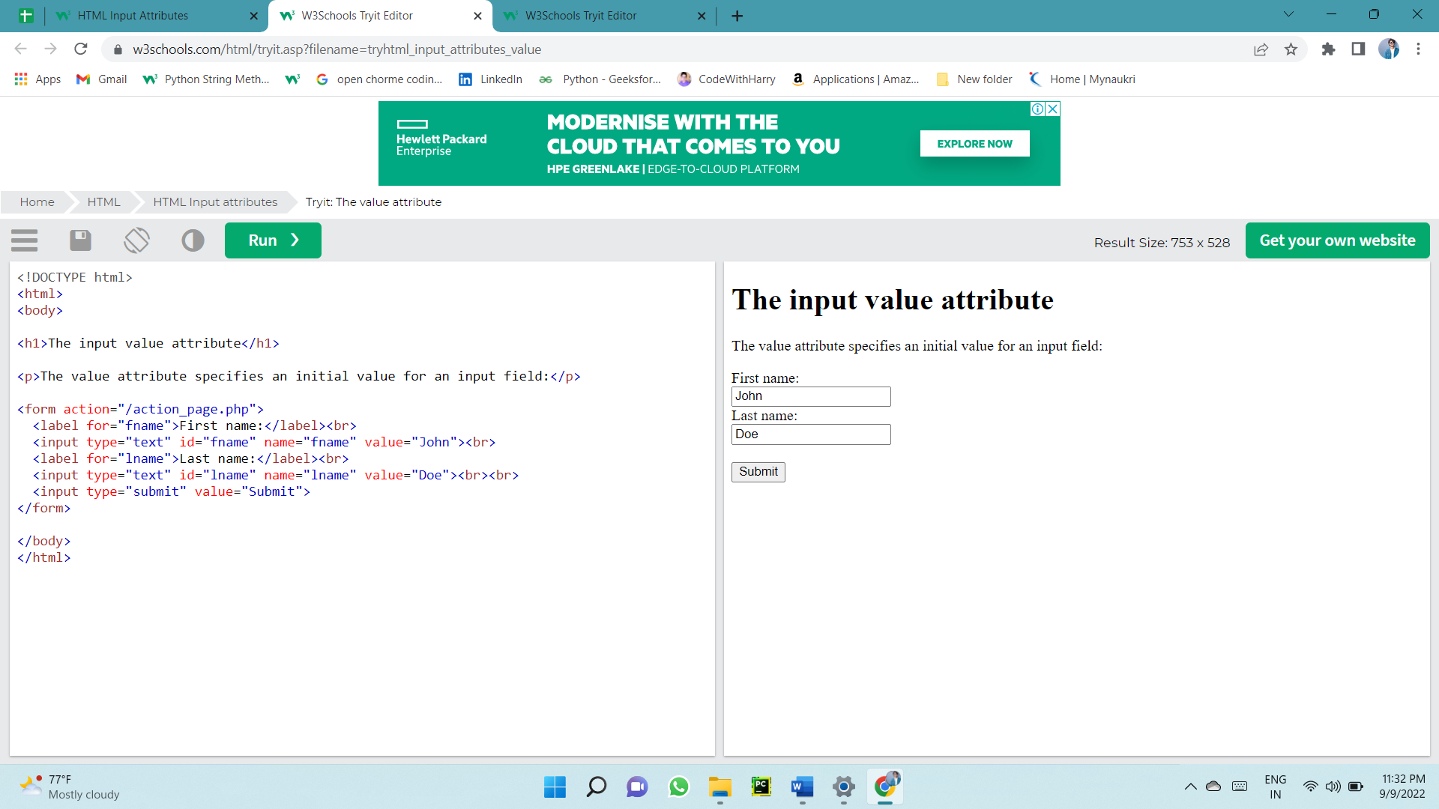The input value attribute specifies an initial value for an input field:

### The readonly Attribute

The input readonly attribute specifies that an input field is read-only.

A read-only input field cannot be modified (however, a user can tab to it, highlight it, and copy the text from it).

The value of a read-only input field will be sent when submitting the form!

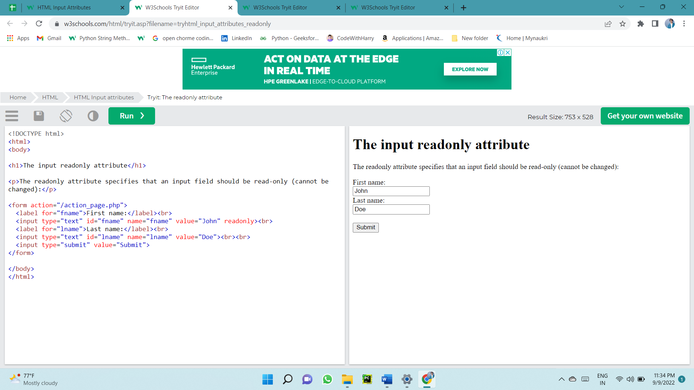

### The disabled Attribute

The input disabled attribute specifies that an input field should be disabled.

A disabled input field is unusable and un-clickable.

The value of a disabled input field will not be sent when submitting the form!

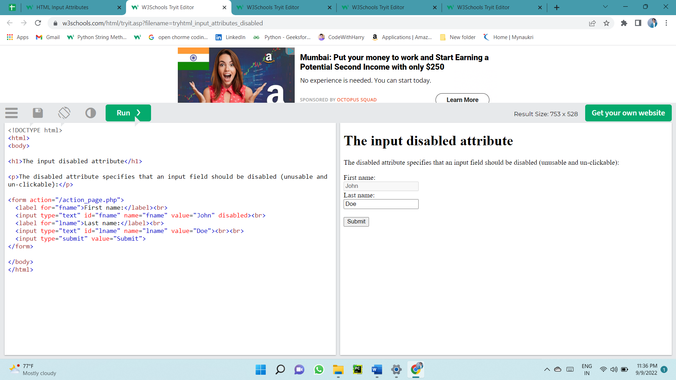

### The size Attribute

The input size attribute specifies the visible width, in characters, of an input field.

The default value for size is 20.

Note: The size attribute works with the following input types: text, search, tel, url, email, and password.

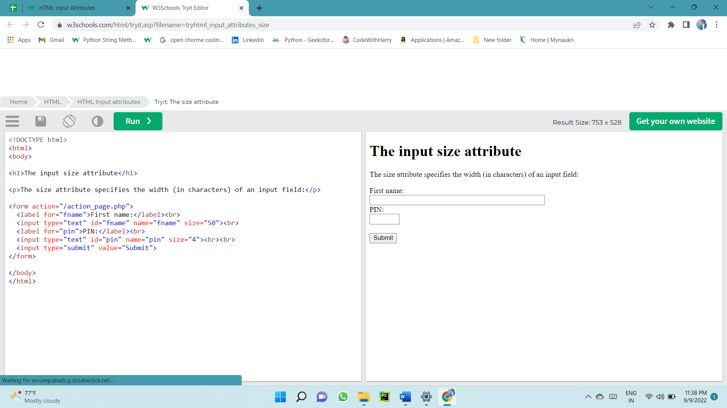

### The maxlength Attribute

The input maxlength attribute specifies the maximum number of characters allowed in an input field.

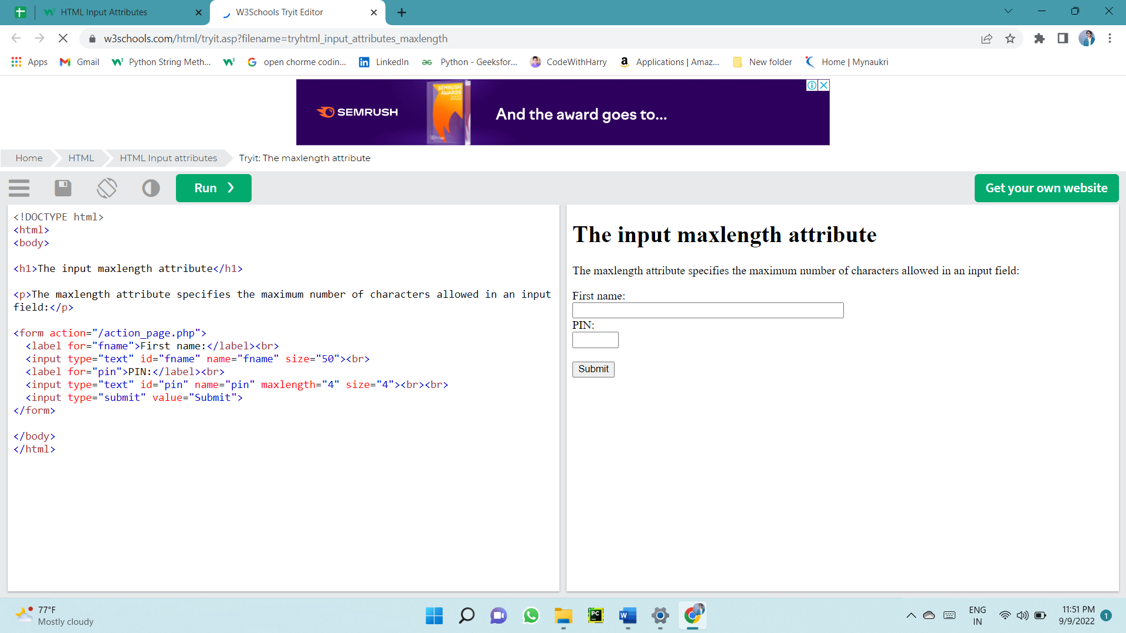Note: When a maxlength is set, the input field will not accept more than the specified number of characters. However, this attribute does not provide any feedback. So, if you want to alert the user, you must write JavaScript code.

### The min and max Attributes

The input min and max attributes specify the minimum and maximum values for an input field.

The min and max attributes work with the following input types: number, range, date, datetime-local, month, time and week.

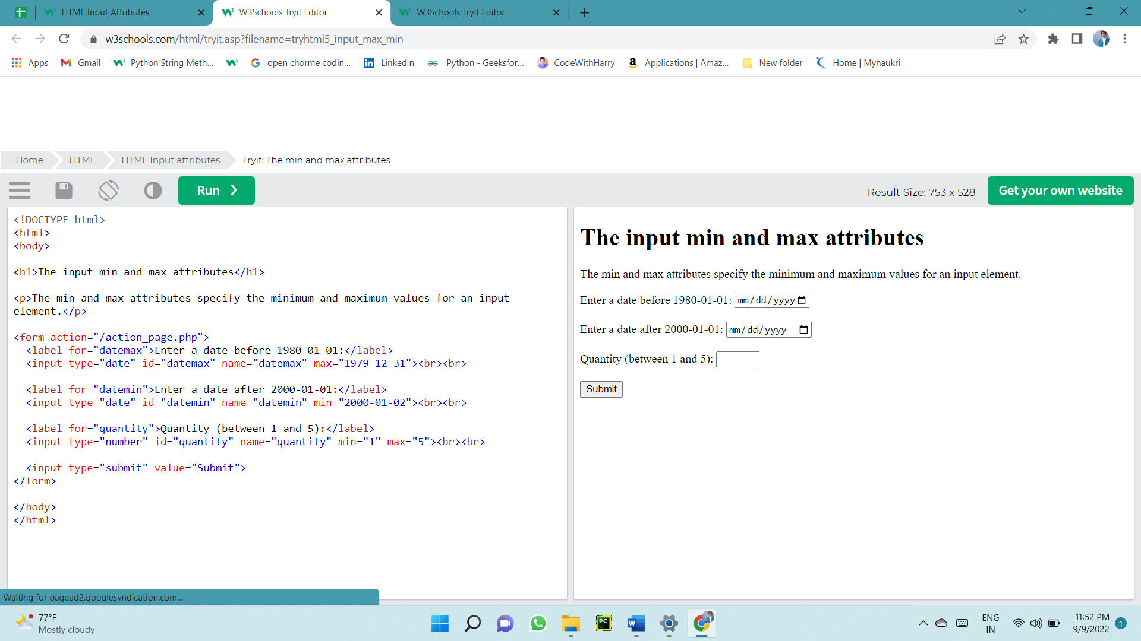Tip: Use the max and min attributes together to create a range of legal values.

### The multiple Attribute

The input multiple attribute specifies that the user is allowed to enter more than one value in an input field.

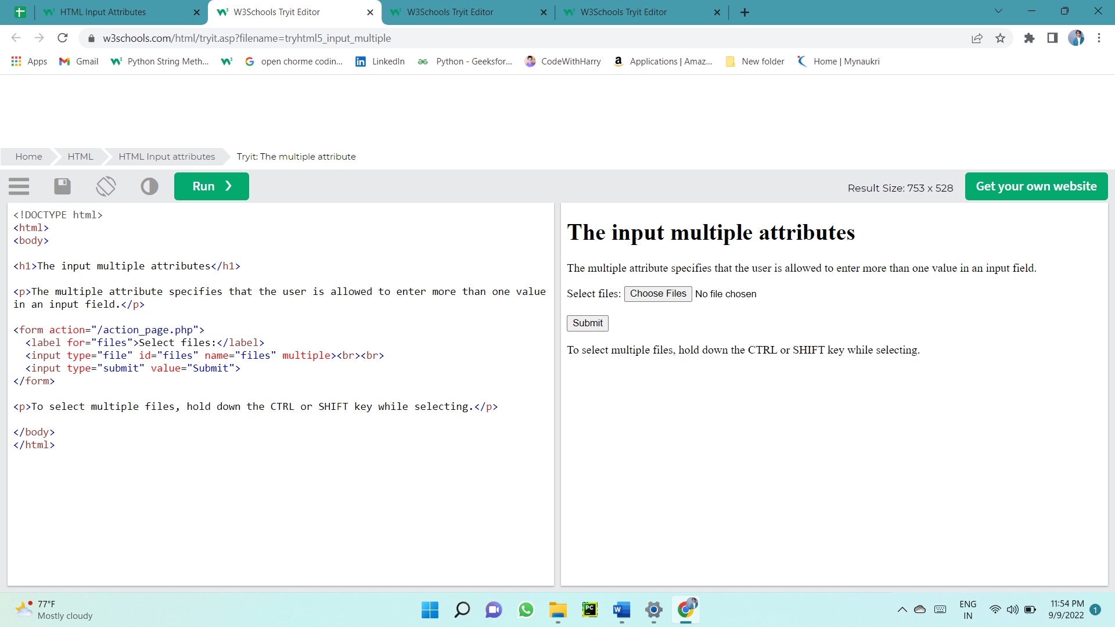The multiple attribute works with the following input types: email, and file.

### The pattern Attribute

The input pattern attribute specifies a regular expression that the input field's value is checked against, when the form is submitted.

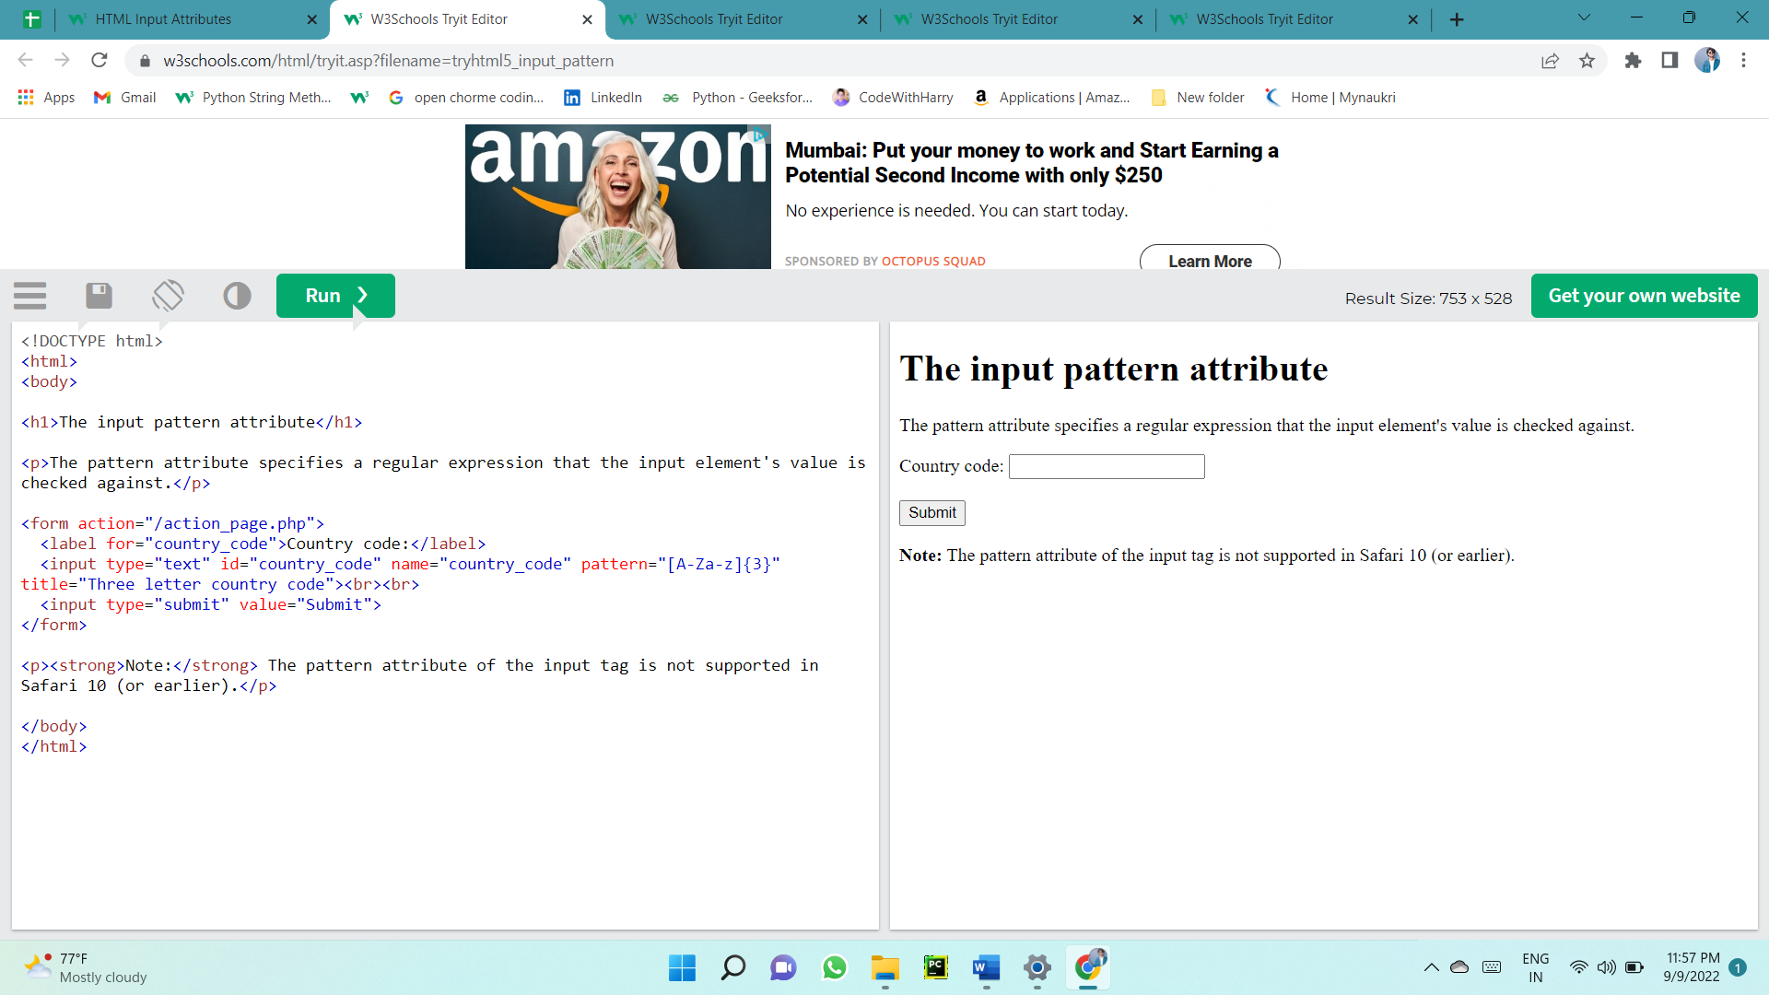The pattern attribute works with the following input types: text, date, search, url, tel, email, and password.

### The placeholder Attribute

The input placeholder attribute specifies a short hint that describes the expected value of an input field (a sample value or a short description of the expected format).

The short hint is displayed in the input field before the user enters a value.

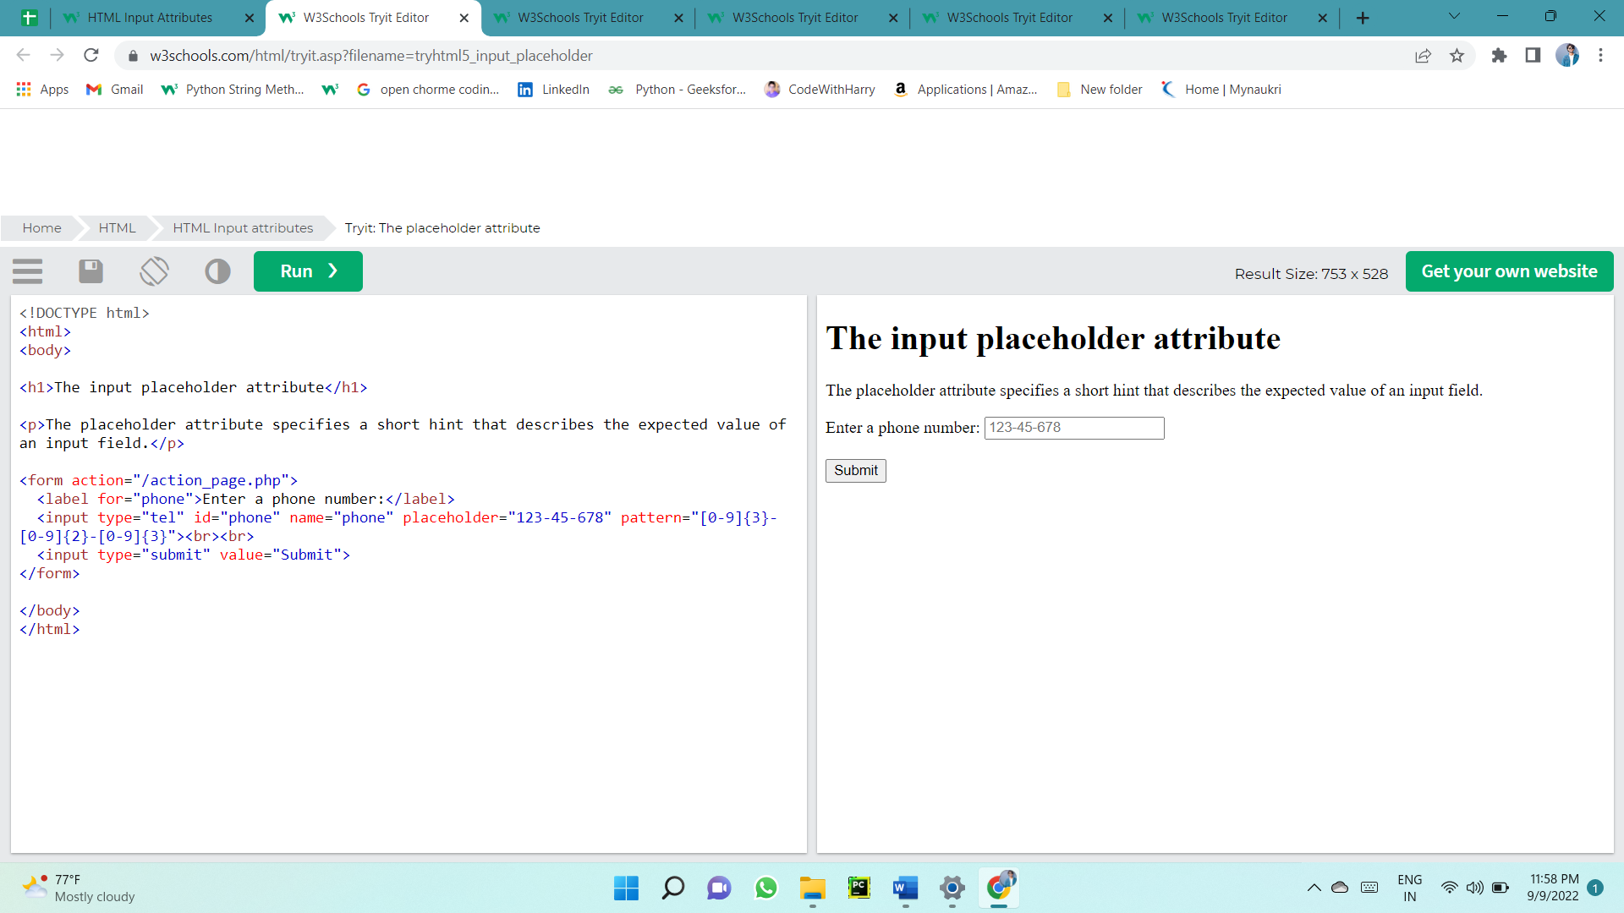The placeholder attribute works with the following input types: text, search, url, tel, email, and password.

### The required Attribute

The input required attribute specifies that an input field must be filled out before submitting the form.

The required attribute works with the following input types: text, search, url, tel, email, password, date pickers, number, checkbox, radio, and file.

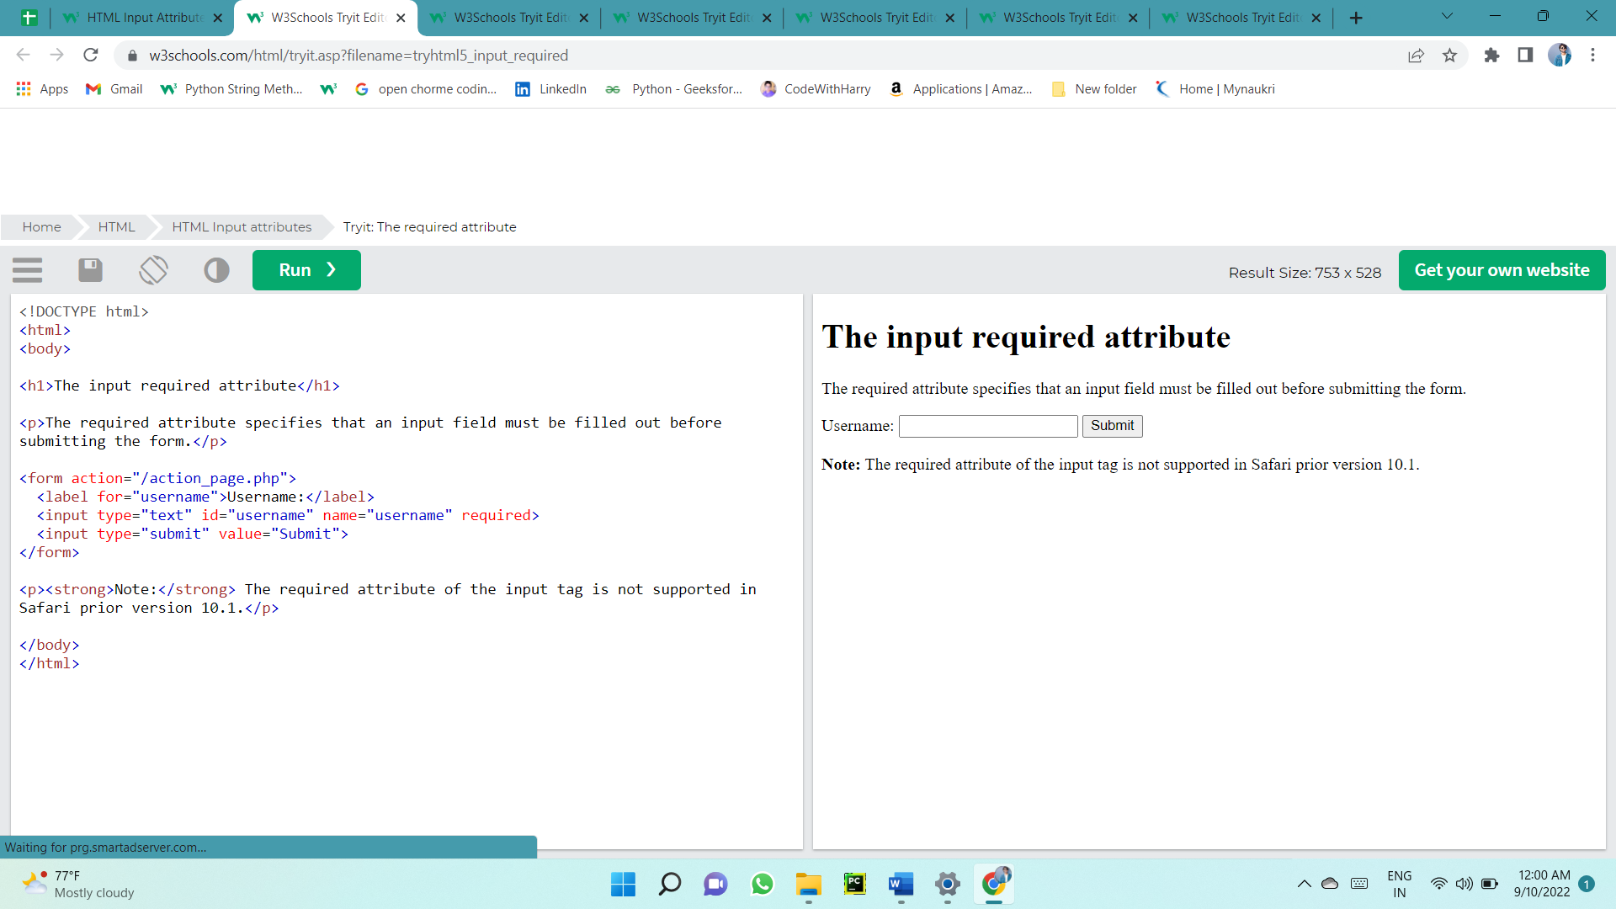

### The step Attribute

The input step attribute specifies the legal number intervals for an input field.

Example: if step="3", legal numbers could be -3, 0, 3, 6, etc.

**Tip:** This attribute can be used together with the max and min attributes to create a range of legal values.

The step attribute works with the following input types: number, range, date, datetime-local, month, time and week.



### The autofocus Attribute

The input autofocus attribute specifies that an input field should automatically get focus when the page loads.



### The list Attribute

The input list attribute refers to a <datalist> element that contains pre-defined options for an <input> element.



### The autocomplete Attribute

The input autocomplete attribute specifies whether a form or an input field should have autocomplete on or off.

Autocomplete allows the browser to predict the value. When a user starts to type in a field, the browser should display options to fill in the field, based on earlier typed values.

The autocomplete attribute works with <form> and the following <input> types: text, search, url, tel, email, password, datepickers, range, and color.

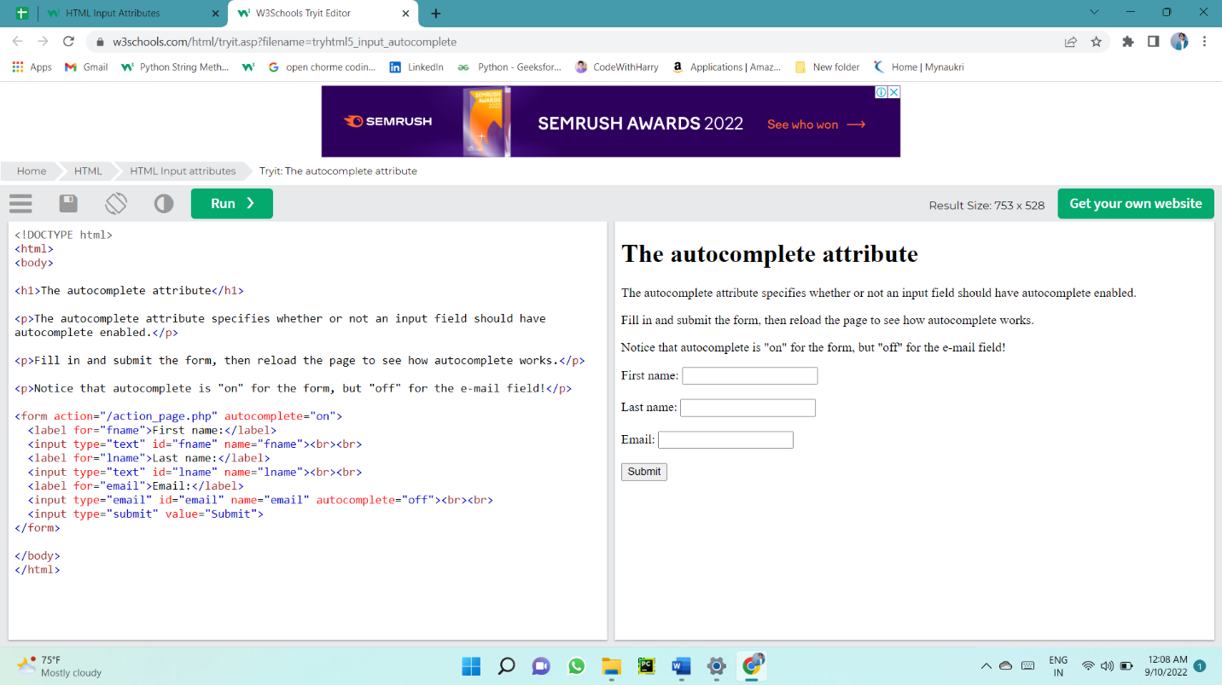

# **HTML Favicon**

You can use any image you like as your favicon

Step –

First select a image go to favion generator .

Uploade that image , copy html code and paste 

# **How to add or link style tag with html .**

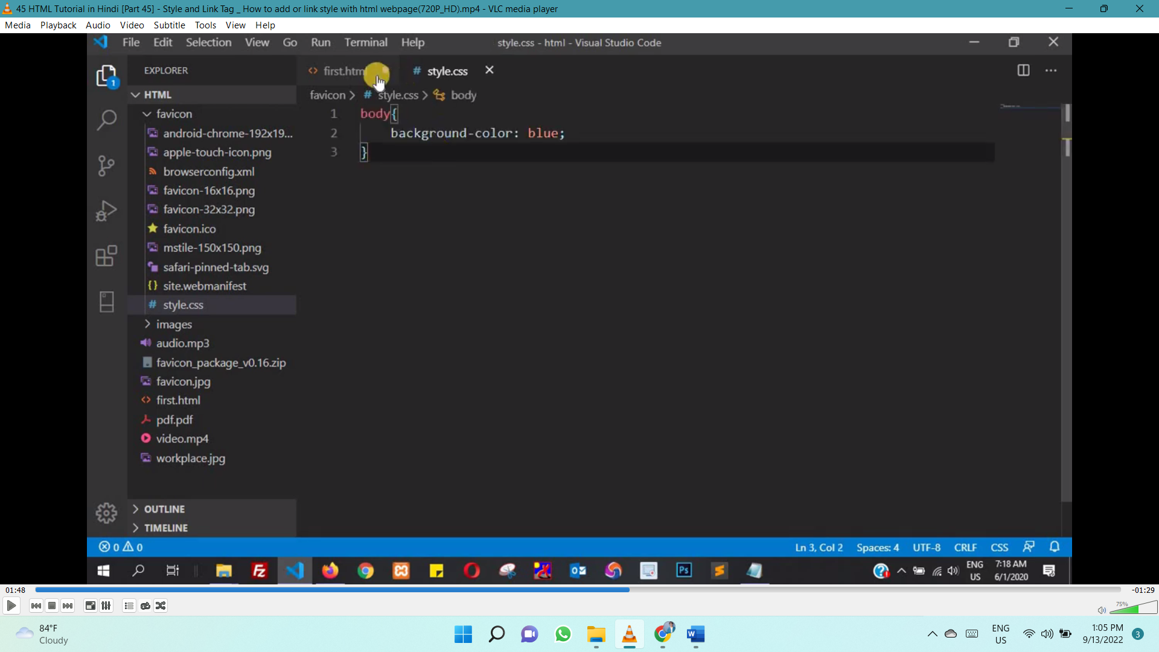

# **How to add JS IN html**

# **(OG TAG OPEN GRAPH TAG FACEBOOK) AND (TWITTER CARD TAG)**

# **RIGHT TO LEFT A WEB PAGE (AREBIC LANGUAGE)**

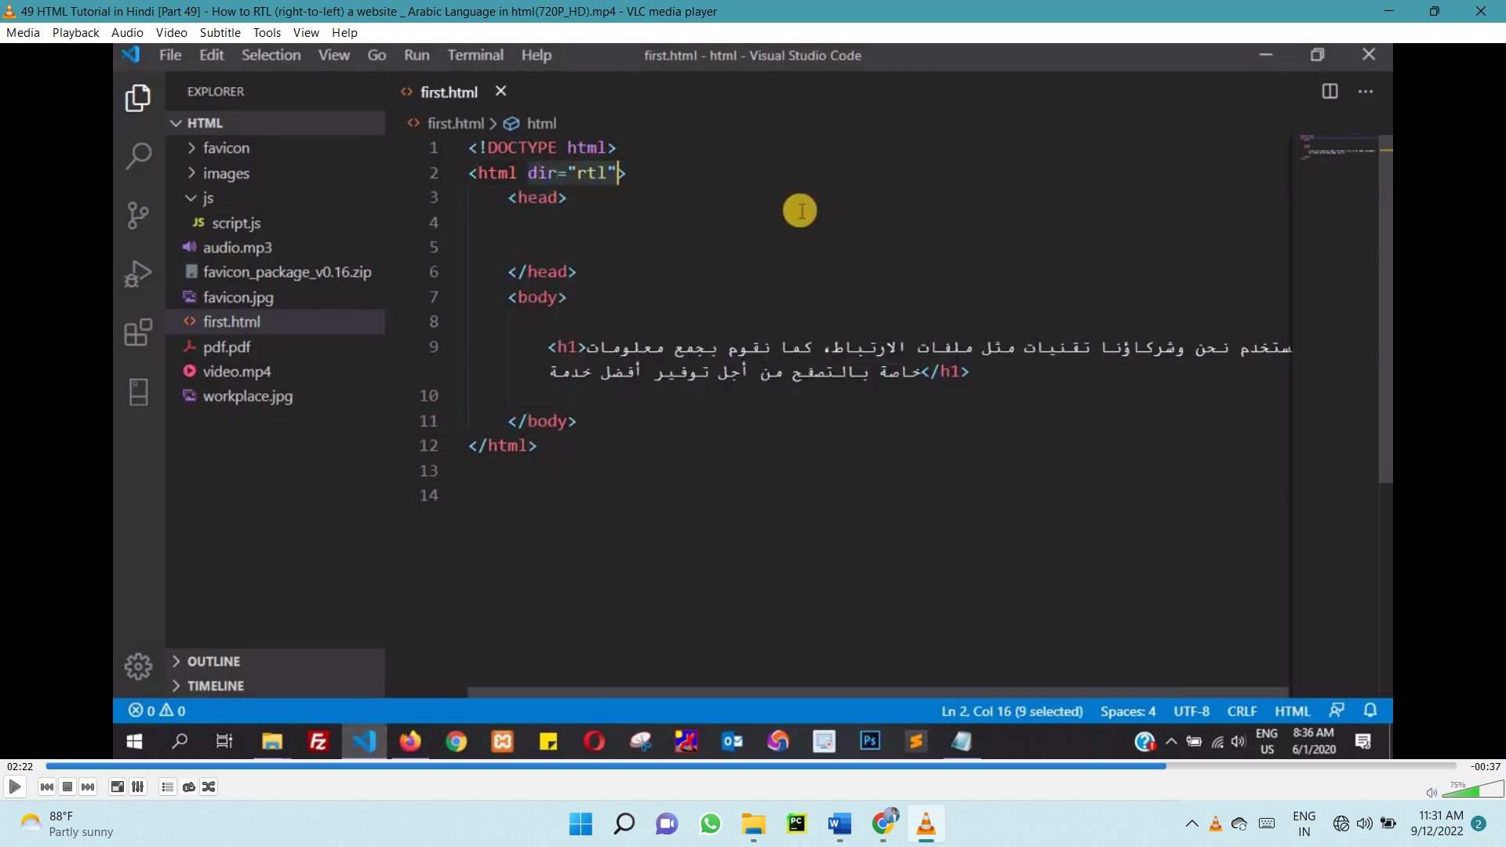

# **W3C AND W3C MARKUP VALIADATION**

GO TO SITE W3C

AND COPY PASTE HTML TO CHECK error in code

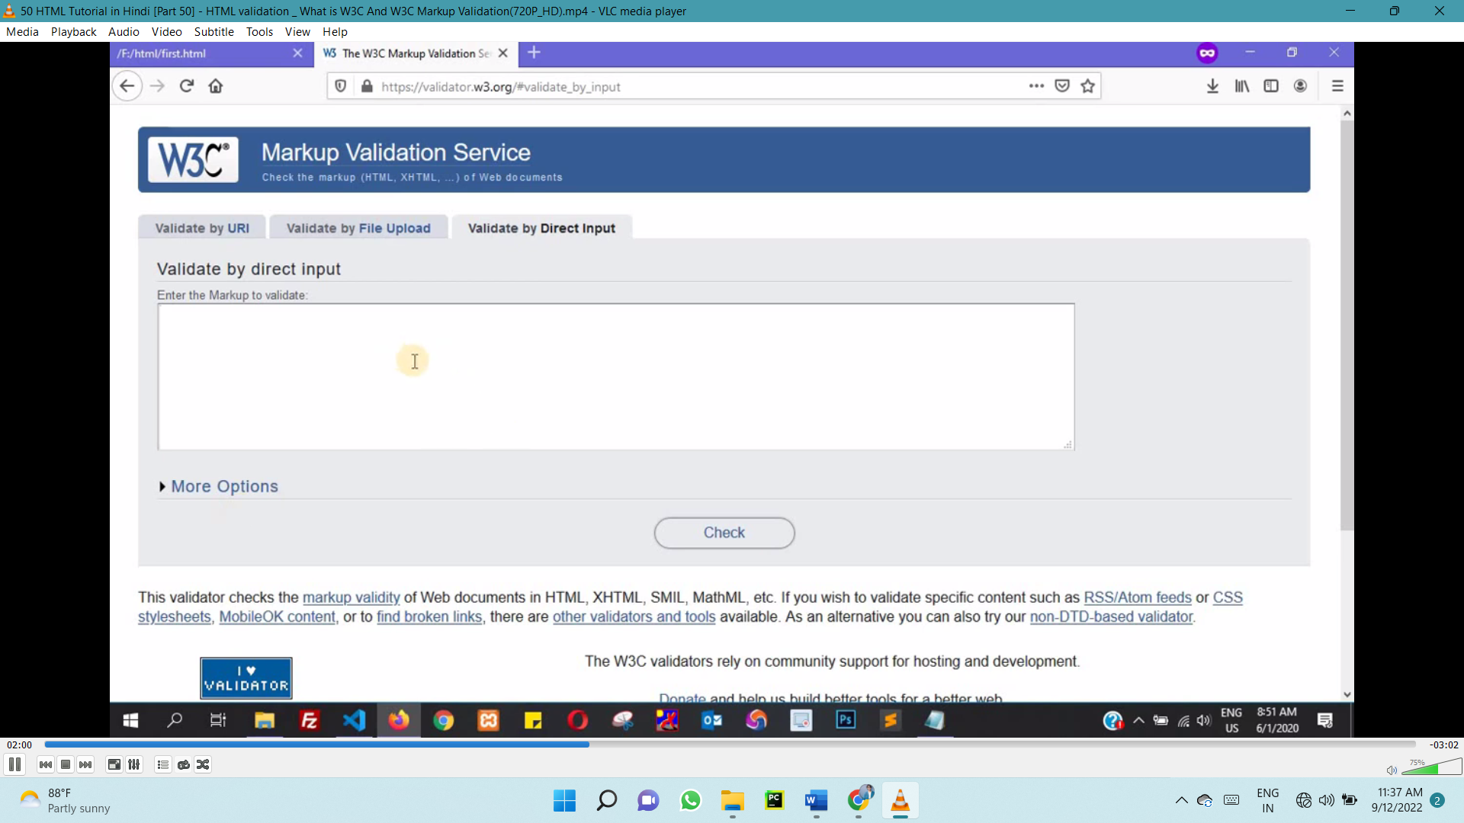

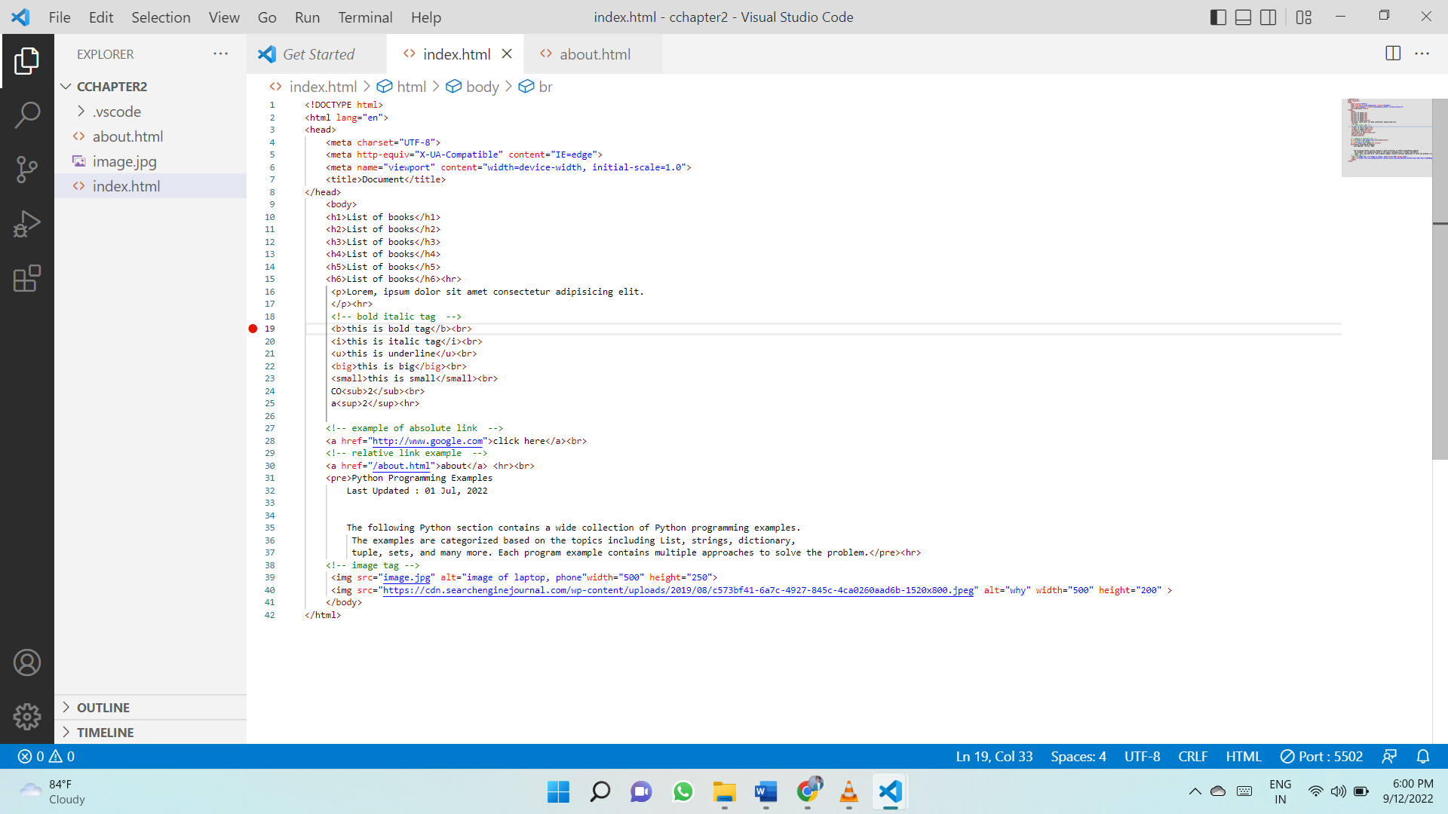

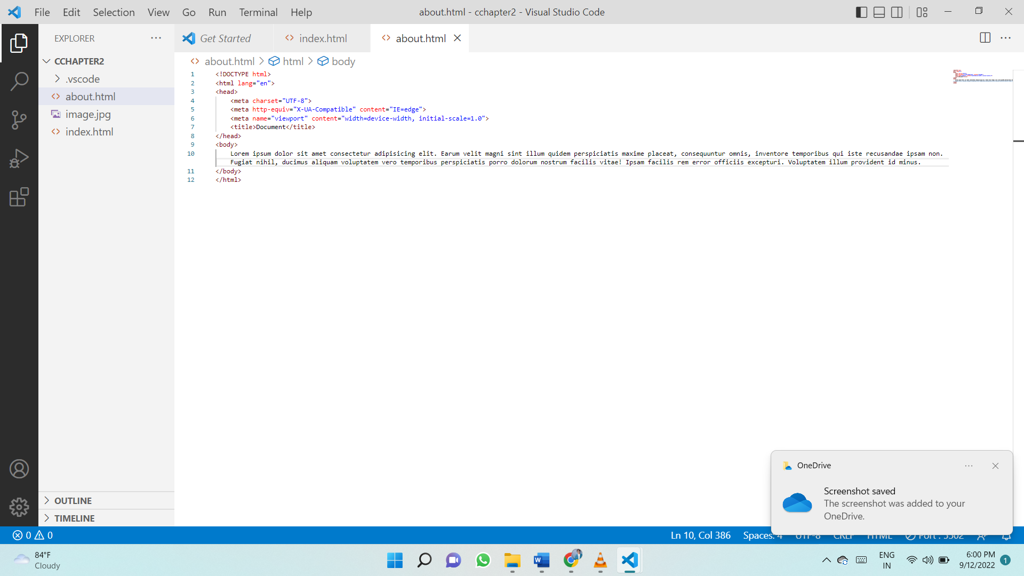

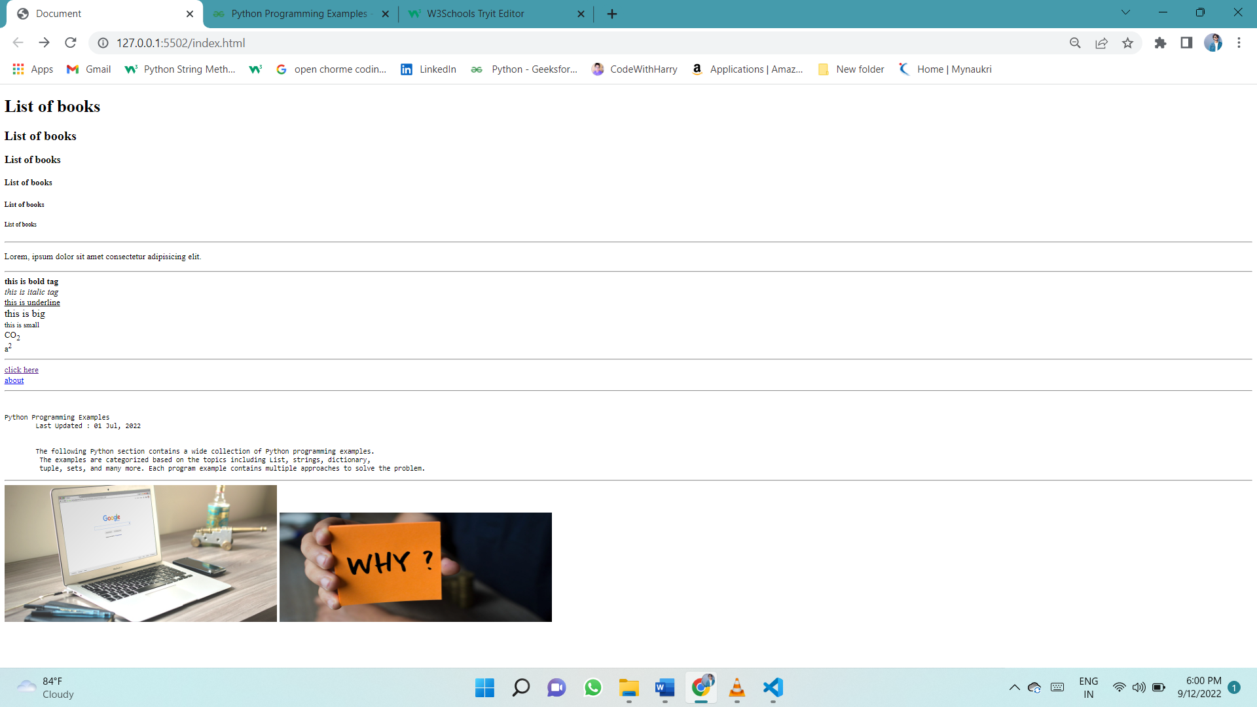output

# **HTML Encoding (Character Sets)**

To display an HTML page correctly, a web browser must know which character set to use.

To display an HTML page correctly, a web browser must know the character set used in the page.

This is specified in the <meta> tag:

<meta charset="UTF-8">

# **HTML Uniform Resource Locators (URL)**

A URL is another word for a web address.

A URL can be composed of words (e.g. w3schools.com), or an Internet Protocol (IP) address (e.g. 192.68.20.50).

Most people enter the name when surfing, because names are easier to remember than numbers.

## URL - Uniform Resource Locator

Web browsers request pages from web servers by using a URL.

A Uniform Resource Locator (URL) is used to address a document (or other data) on the web.

A web address like <https://www.w3schools.com/html/default.asp> follows these syntax rules:

scheme://prefix.domain:port/path/filename

Explanation:

* **scheme** - defines the **type** of Internet service (most common is **http or https**)
* prefix - defines a domain **prefix** (default for http is **www**)
* **domain** - defines the Internet **domain name**(like w3schools.com)
* **port** - defines the **port number**at the host (default for http is **80**)
* **path** - defines a **path** at the server (If omitted: the root directory of the site)
* **filename** - defines the name of a document or resource

**Common URL Schemes**

|  |  |  |
| --- | --- | --- |
| **Scheme** | **Short for** | **Used for** |
| http | HyperText Transfer Protocol | Common web pages. Not encrypted |
| https | Secure HyperText Transfer Protocol | Secure web pages. Encrypted |
| ftp | File Transfer Protocol | Downloading or uploading files |
| file |  | A file on your computer |

table below lists some common schemes:

## URL Encoding

URLs can only be sent over the Internet using the [ASCII character-set](https://www.w3schools.com/charsets/ref_html_ascii.asp). If a URL contains characters outside the ASCII set, the URL has to be converted.

URL encoding converts non-ASCII characters into a format that can be transmitted over the Internet.

URL encoding replaces non-ASCII characters with a "%" followed by hexadecimal digits.

URLs cannot contain spaces. URL encoding normally replaces a space with a plus (+) sign, or %20.